PRESS RELEASE

Würth Elektronik expands its REDEXPERT online simulation tool with the MagI³C Power Module Designer
Power module design-in made easy
Waldenburg (Germany), March 14, 2024 – REDEXPERT, the online platform for the simple selection, simulation, and design-in of Würth Elektronik components, now features a new function. The MagI³C Power Module Designer enables the swift and hassle-free integration of a power module into an application without requiring special DC/DC converter skills. The tool guides developers step-by-step through the entire selection and configuration process. The automatically created design proposal is rendered as a PDF file, together with a list of the components required. The tool also offers an option for the direct order of samples of selected Würth Elektronik components.
Whenever you wish to use a MagI³C power module in the development of an application, the intuitive input mask guides you through the selection process, which asks you to enter the requirements of the application, such as input and output voltage and load current. After answering questions about whether the voltage supply needs to be galvanically isolated, you’re presented with an initial proposal for a suitable MagI³C power module. This proposal then forms the basis for the individual configuration of parameters; for example potentiometers for the output voltage, input and output capacitors, or switching frequency. The data for the application are then used to run a simulation of the power module, enabling you to analyse its performance parameters of the power module, such as efficiency, output-voltage ripple, and input-current consumption.
The design proposal can then be used to order the required samples directly from Würth Elektronik, which delivers components for pilot and serial production runs directly ex stock without any minimum order quantity.

Available images
The following images can be downloaded from the Internet in printable quality: https://kk.htcm.de/press-releases/wuerth/
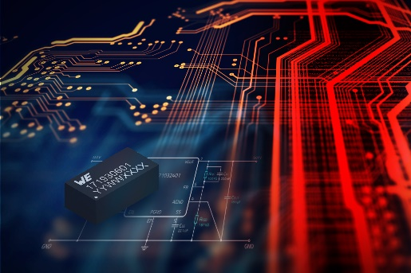
Image source: Würth Elektronik
New in REDEXPERT: the MagI³C Power Module Designer

Available video material
A video on this topic can be found at:
REDEXPERT MagI³C Designer - Power Module Design-In Made Easy (we-online.com)
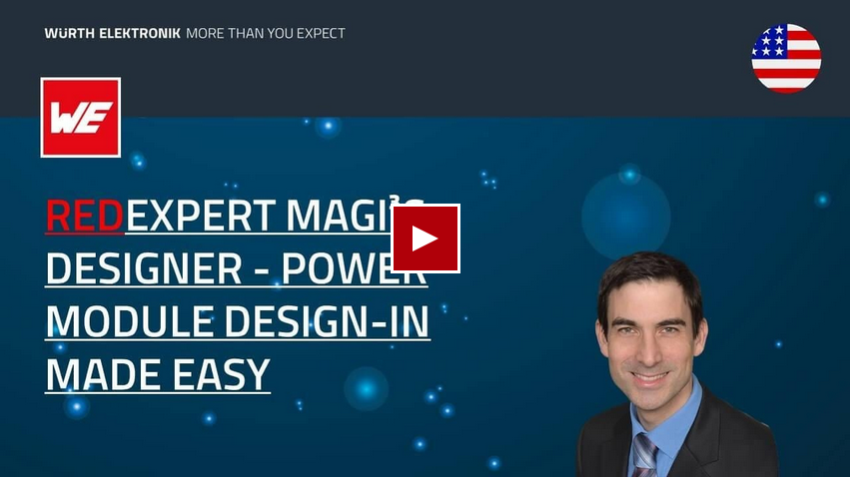
Source: Würth Elektronik
Webinar: Introduction of MagI³C Power Module Designer in REDEXPERT

About the Würth Elektronik eiSos Group
Würth Elektronik eiSos Group is a manufacturer of electronic and electromechanical components for the electronics industry and a technology company that spearheads pioneering electronic solutions. Würth Elektronik eiSos is one of the largest European manufacturers of passive components and is active in 50 countries. Production sites in Europe, Asia and North America supply a growing number of customers worldwide.
The product range includes EMC components, inductors, transformers, RF components, varistors, capacitors, resistors, quartz crystals, oscillators, power modules, Wireless Power Transfer, LEDs, sensors, radio modules, connectors, power supply elements, switches, push-buttons, connection technology, fuse holders and solutions for wireless data transmission. The portfolio is complemented by customized solutions.
The unrivaled service orientation of the company is characterized by the availability of all catalog components from stock without minimum order quantity, free samples and extensive support through technical sales staff and selection tools.
Würth Elektronik is part of the Würth Group, the global market leader in the development, production, and sale of fastening and assembly materials, and employs 7,900 people. In 2023, the Würth Elektronik Group generated sales of 1.24 Billion Euro.
Würth Elektronik: more than you expect!
Further information at www.we-online.com

Further information:  Würth Elektronik eiSos GmbH & Co. KG  Sarah Hurst  Clarita-Bernhard-Strasse 9  81249 Munich  Germany  Phone: +49 7942 945-5186  E-mail: sarah.hurst@we-online.de  www.we-online.com | Press contact:  HighTech communications GmbH  Brigitte Basilio  Brunhamstrasse 21  81249 Munich  Germany  Phone: +49 89 500778-20  E-mail: b.basilio@htcm.de  www.htcm.de

