PRESS RELEASE

Würth Elektronik eiSos Returns to APEC
Engaging Attendees and Showcasing Innovations
Watertown (USA), March 7, 2024 – Würth Elektronik eiSos made its return to the prestigious Applied Power and Electronics Conference (APEC) held in Long Beach, California, USA, in February 2024. With a history spanning over 35 years, APEC has solidified its position as the premier showcase for electronic components in North America. Prior to the exhibition, technical minds met at the PSMA/PELS Power Magnetics workshop, where Würth Elektronik displayed a strong presence.
Seminars/Presentations
At APEC, George Slama, Senior Application and Content Engineer at Würth Elektronik, assumed the role of Session Chair for Industry Sessions such as "Modeling and Simulation of Magnetics - Closing the Loop" and "EMI & Magnetics." Slama also reprised his role as Technical Dialog Session Chair for "High Frequency Magnetics" and "Magnetic Design & Optimization" sessions. Slama displayed his technical knowledge during an Exhibitor Presentation as he hosted “Advancements in EMC Filter and Component Selection Tool” during the exhibition.
Also representing the company, Matt Wilkowski, Design Consultant for Würth Elektronik, served as Technical Dialogue Session Chair for Tuesday's "High Frequency Magnetics" and "Magnetics Applications II" sessions, along with being the Technical Lecture Session Chair for "Magnetics & Modeling Simulation" and "Magnetics Applications I" on Thursday.
During the conference, Würth Elektronik's Global Business Consultant, Lorandt Foelkel, delivered an Industry Session titled "See the Power of IoT in Action! Live, Functional Demo of Solutions." Additionally, seasoned Application Engineer Jared Quenzer hosted a Professional Education Seminar, "EMC Workshop for Power Supply Designers," which kicked off the week on Sunday, February 25.
The Booth
During the show, Würth Elektronik released the newest edition of their guidebook; “The Trilogy of Wireless Power Transfer 2nd edition.” Cem Som, author of the guidebook, was available on the booth to answer technical questions and offer support. Also released in Long Beach is Würth Elektronik’s comprehensive manual, “DC/DC Handbook.”

"Our more-than-you-expect service was and is the foundation of Würth Elektronik's corporate success," confirms Alexander Gerfer, CTO of the Würth Elektronik eiSos Group, a well-known component manufacturer. "Our DC/DC Converter Handbook, which we presented for the first time at the conference, proves that we are serious about promoting innovation and knowledge transfer. True to our mission "creating together", we will continue to ensure that great ideas get the right power - through functional power supplies as well as targeted development support, especially for start-ups."
Throughout the duration of the exhibition, Würth Elektronik showcased a variety of partner demonstrations on their distinctive booth. Highlighted activities included an interactive 50W WPC Shuffleboard table in collaboration with Infineon Technology, a miniature Ferris Wheel powered by a 24V Brushless DC Motor featuring customizable LED lighting in partnership with Renesas, and an engaging bean bag demonstration game showcasing Texas Instruments Power and Motor Control Solutions.
Attendees who actively participated in the booth's interactive activities received a complimentary pair of Würth Elektronik branded socks and were entered for a chance to win a pair of Apple Air Pods.
In addition to exploring the interactive exhibits, APEC attendees had the opportunity to engage in technical discussions with Würth Elektronik experts, receive the iconic Würth Elektronik APEC hat, and secure an exclusive invitation to one of the exhibition's premier events: the highly anticipated Tuesday Night Party hosted by Würth Elektronik.

Available images
The following images can be downloaded from the Internet in printable quality: https://kk.htcm.de/press-releases/wuerth/
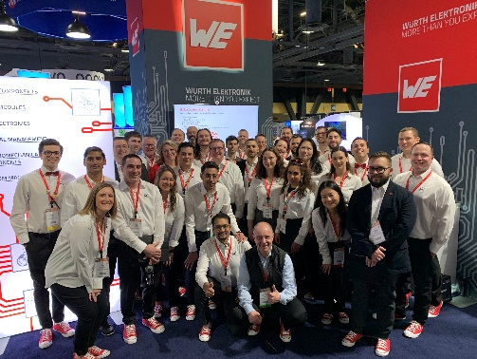Image source: Wurth Electronics  The team and Alexander Gerfer, CTO of the Würth Elektronik eiSos Group (kneeling in the center front). | 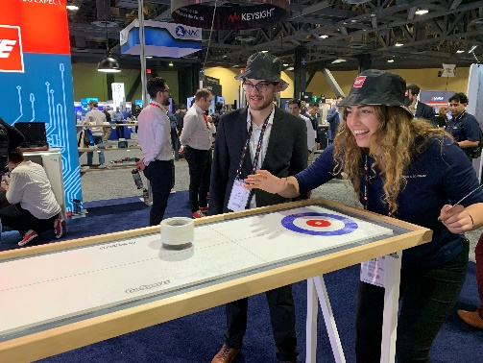  Image source: Wurth Electronics  Let's have some fun at the booth.

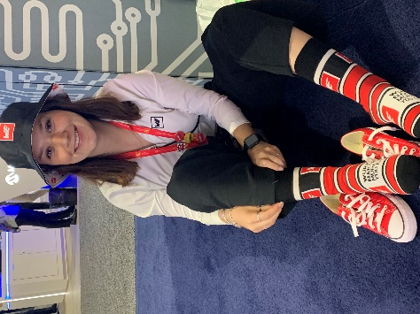Image source: Wurth Electronics  Now a cult: The Würth Elektronik socks. | 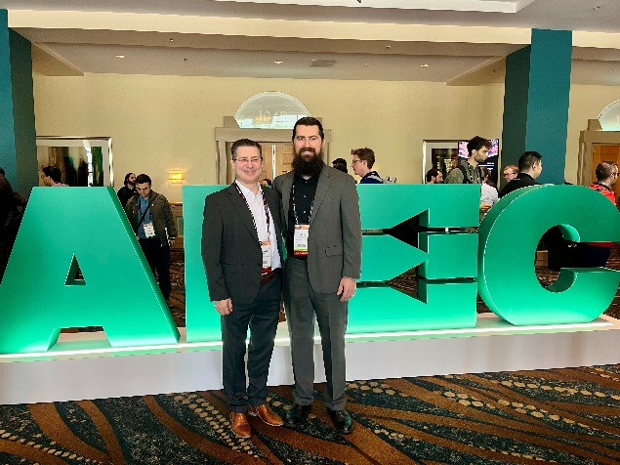  Image source: Wurth Electronics  Two gifted Würth Elektronik technology communicators: Lorandt Foelkel and Jared Quenzer (from left).

About the Würth Elektronik eiSos Group
Würth Elektronik eiSos Group is a manufacturer of electronic and electromechanical components for the electronics industry and a technology company that spearheads pioneering electronic solutions. Würth Elektronik eiSos is one of the largest European manufacturers of passive components and is active in 50 countries. Production sites in Europe, Asia and North America supply a growing number of customers worldwide.
The product range includes EMC components, inductors, transformers, RF components, varistors, capacitors, resistors, quartz crystals, oscillators, power modules, Wireless Power Transfer, LEDs, sensors, radio modules, connectors, power supply elements, switches, push-buttons, connection technology, fuse holders and solutions for wireless data transmission. The portfolio is complemented by customized solutions.
The unrivaled service orientation of the company is characterized by the availability of all catalog components from stock without minimum order quantity, free samples and extensive support through technical sales staff and selection tools.
Würth Elektronik is part of the Würth Group, the global market leader in the development, production, and sale of fastening and assembly materials, and employs 7,900 people. In 2023, the Würth Elektronik Group generated sales of 1.24 Billion Euro.
Würth Elektronik: more than you expect!
Further information at www.we-online.com

Further information:  Wurth Electronics Midcom, Inc.  Amelia Thompson  121 Airport Drive  PO Box 1330  Watertown, SD 57201 USA  Phone: +1 605 886 4385  Toll-free (in the U.S.):  Phone: +1 800 643 2661  E-mail: amelia.thompson@we-online.com  www.we-online.com | Press contact:  HighTech communications GmbH  Brigitte Basilio  Brunhamstrasse 21  81249 Munich  Germany  Phone: +49 89 500778-20  E-mail: b.basilio@htcm.de  www.htcm.de

