Würth Elektronik presents social plan for printed circuit board production in Schopfheim

In October 2024, Würth Elektronik Circuit Board Technology announced the planned closure of PCB production at the Schopfheim site. The management and works council have now reached an agreement on a reconciliation of interests and a social plan, which was presented to the affected employees at a works meeting on Thursday, February 6, 2025.

"We are delighted about the important, successful conclusion of the negotiations and that we have thus found a socially acceptable solution for the employees affected," says Andreas Gimmer, Managing Director of Würth Elektronik Circuit Board Technology.

The decisive factor for the closure of PCB production at the Schopfheim site is the current worst crisis in the history of the PCB industry in Europe, with a dramatic slump in incoming orders. After the closure was announced, numerous companies from the region and neighboring Switzerland contacted us with job offers for the employees in Schopfheim. Würth Elektronik used the contact for an internal job exchange. To date, almost all trainees and around 50 employees have been successfully placed.

The products previously manufactured in Schopfheim will in future be produced at other Würth Elektronik locations in Germany. The production sites in Niedernhall and Rot am See will focus on industries and applications whose more complex and individual printed circuit boards are manufactured in Europe for strategic reasons. Comprehensive PCB-related services will be retained in order to support customers from the product idea to the finished product. The consolidation of the production sites enables stable capacity utilization at the other plants in Germany and a focus on an economically sound future for Würth Elektronik Circuit Board Technology.

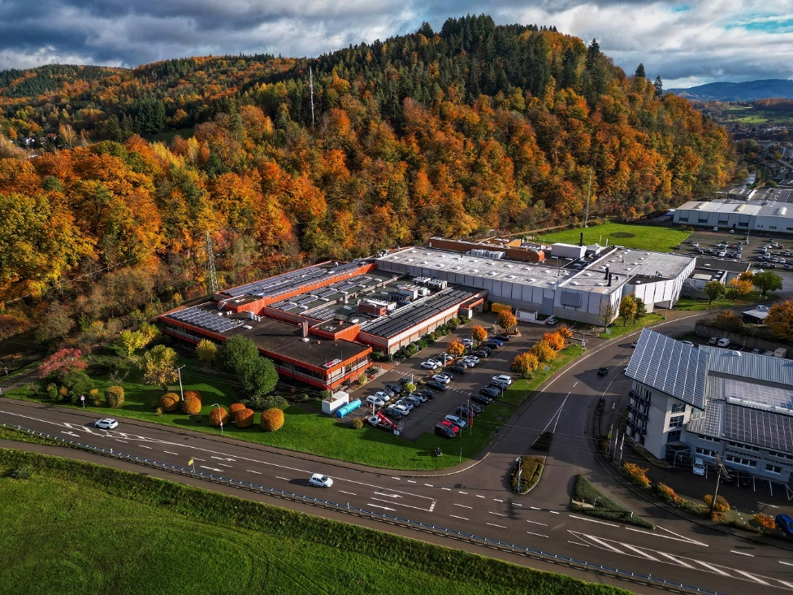

Figure 1: The circuit board production of Würth Elektronik Circuit Board Technology in Schopfheim is closed. (Source: Würth Elektronik Circuit Board Technology)

*About Würth Elektronik Circuit Board Technology*

*Founded in 1971, Würth Elektronik Circuit Board Technology is now one of the leading PCB manufacturers in Europe, with national and international sales teams, 1,000 employees, 4,000 customers and an annual turnover in the three-digit million range. Production currently takes place at three German sites and with qualified partners in Asia. Whether basic or high-end technologies, customer-specific requirements are met, from prototypes and samples to medium and large series. By developing innovative product technologies, the company qualifies itself as a pioneer on the market. Experts from a wide range of business areas provide intensive advice and support, from the initial idea to the finished product and beyond. Würth Elektronik Circuit Board Technology sees itself as a reliable partner for both individual entrepreneurs and large corporations.*