PRESS RELEASE
Würth Elektronik Turkey supports forestation project
A new tree is growing for every order of electronics
Waldenburg (Germany), 13 October 2021 – The Turkish office of Würth Elektronik plants a tree for every order of electronic components. Through the "Breath of the Future" campaign, a forest with 10,000 trees is to grow in the Antalya region by next year. Würth Elektronik is cooperating with OGEM-VAK, the "Foundation for Supporting Forestry Development and Combating Forest Fires". The first 3,000 saplings have already been planted.
"The last forest fire disaster reminded all of us again how incredibly important the work of OGEM-VAK is," says Merze Yegen, Customer Relations Executive, at Würth Elektronik eiSos. "Our customers are happy to receive a certificate as a ‘thank you’ saying, for example, 'Würth Elektronik has donated 14 saplings for a greener Turkey in your name for the Breath of the Future campaign.'"

Available images
The following images can be downloaded from the Internet in printable quality: https://kk.htcm.de/press-releases/wuerth/
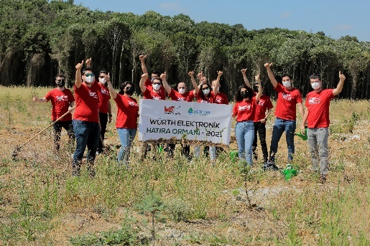Image source: Würth Elektronik  Together with the OGEM-VAK Foundation, Würth Elektronik is working on a forestation project in Turkey. | 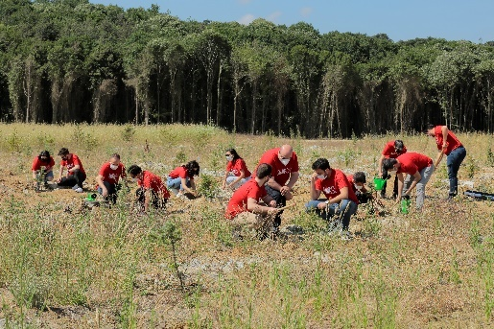  Image source: Würth Elektronik  Employees of the Würth Elektronik office in Turkey planting tree saplings.

About OGEM-VAK
OGEM-VAK is a foundation established in Ankara in 1996 to take care of the professional, economic and cultural needs of the staff of the General Directorate of Forestry and to provide services. It takes social and economic measures to make citizens of all ages aware of the protection of forests and forestry. It cooperates with all institutions, foundations and individuals that serve this purpose. OGEM-VAK has started to receive seedling donations and contribute to reforestation activities through the establishment of memorial forests, within the framework of the protocol of cooperation in reforestation signed with the General Directorate of Forestry in 2019.

About the Würth Elektronik eiSos Group
Würth Elektronik eiSos Group is a manufacturer of electronic and electromechanical components for the electronics industry and a technology company that spearheads pioneering electronic solutions. Würth Elektronik eiSos is one of the largest European manufacturers of passive components and is active in 50 countries. Production sites in Europe, Asia and North America supply a growing number of customers worldwide.
The product range includes EMC components, inductors, transformers, RF components, varistors, capacitors, resistors, quartz crystals, oscillators, power modules, Wireless Power Transfer, LEDs, sensors, connectors, power supply elements, switches, push-buttons, connection technology, fuse holders and solutions for wireless data transmission.
The unrivaled service orientation of the company is characterized by the availability of all catalog components from stock without minimum order quantity, free samples and extensive support through technical sales staff and selection tools.
Würth Elektronik is part of the Würth Group, the world market leader for assembly and fastening technology. The company employs 7,300 staff and generated sales of 823 million euros in 2020.
Würth Elektronik: more than you expect!
Further information at www.we-online.com

Further information:  Würth Elektronik eiSos GmbH & Co. KG  Sarah Hurst  Max-Eyth-Strasse 1  74638 Waldenburg  Germany  Phone: +49 7942 945-5186  E-mail: sarah.hurst@we-online.de  www.we-online.com | Press contact:  HighTech communications GmbH  Brigitte Basilio  Brunhamstrasse 21  81249 Munich  Germany  Phone: +49 89 500778-20  Telefax: +49 89 500778-77  E-mail: b.basilio@htcm.de  www.htcm.de

