PRESS RELEASE
Würth Elektronik establishes subsidiary in Korea
The committed technical sales is now a company in Seoul
Waldenburg (Germany), 16 November 2021 – Opening up a new market is difficult, but the Korean team of Würth Elektronik was successful and reached a milestone; the foundation of Wurth Electronics Korea Ltd. The new national subsidiary of the manufacturer of electronic and electromechanical components is located in the Gangseo-gu district in the west of Seoul. By the end of the year, ten employees will be working here.
Industrial customers in Korea were acquired by Würth Elektronik in 2012. The service-oriented sales strategy, tailored to the technical needs of developers, proved successful. The customer base and technical sales team grew continuously. In 2015, investments were made in production capacities for inductors in the Korean market. This year, the sales subsidiary was established; now the official Korean subsidiary of German Würth Elektronik as Wurth Electronics Korea Ltd.
"It is our desire to establish ourselves even more in the market in Korea and strengthen our brand among our customers with service and innovations. With our motto 'more than you expect!', we want to inspire our customers in various sectors such as industry, IoT, medical technology and mobility," says Michon Kim, Managing Director at Wurth Electronics Korea Ltd.

Available image material
The following image material is available for download in printable form on the Internet: https://kk.htcm.de/press-releases/wuerth/

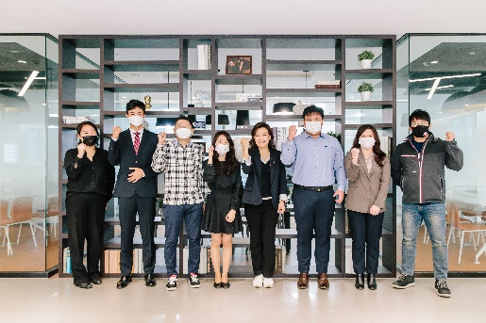Image source: Würth Elektronik
The staff of the Würth Elektronik subsidiary in Korea

About the Würth Elektronik eiSos Group
Würth Elektronik eiSos Group is a manufacturer of electronic and electromechanical components for the electronics industry and a technology company that spearheads pioneering electronic solutions. Würth Elektronik eiSos is one of the largest European manufacturers of passive components and is active in 50 countries. Production sites in Europe, Asia and North America supply a growing number of customers worldwide.
The product range includes EMC components, inductors, transformers, RF components, varistors, capacitors, resistors, quartz crystals, oscillators, power modules, Wireless Power Transfer, LEDs, sensors, connectors, power supply elements, switches, push-buttons, connection technology, fuse holders and solutions for wireless data transmission.
The unrivaled service orientation of the company is characterized by the availability of all catalog components from stock without minimum order quantity, free samples and extensive support through technical sales staff and selection tools.
Würth Elektronik is part of the Würth Group, the world market leader for assembly and fastening technology. The company employs 7,300 staff and generated sales of 823 million euros in 2020.
Würth Elektronik: more than you expect!
Further information at www.we-online.com

Further information:  Würth Elektronik eiSos GmbH & Co. KG  Sarah Hurst  Max-Eyth-Strasse 1  74638 Waldenburg  Germany  Phone: +49 7942 945-5186  E-mail: sarah.hurst@we-online.de  www.we-online.com | Press contact:  HighTech communications GmbH  Brigitte Basilio  Brunhamstrasse 21  81249 Munich  Germany  Phone: +49 89 500778-20  Telefax: +49 89 500778-77  E-mail: b.basilio@htcm.de  www.htcm.de

