PRESS RELEASE
Würth Elektronik significantly expands its thermal management product range
Conducting and Distributing Heat
Waldenburg (Germany), 24 November 2021—Würth Elektronik is increasingly establishing itself as a one-stop shop for thermal interface materials (TIM). Current evidence for this is one series extension and five completely new product groups, which now offer an even greater selection of thermally conductive solutions for bridging between components and heat sinks. These also includes materials for distributing waste heat over larger surfaces. Würth Elektronik offers add-on services for all solutions, such as various forms of assembly and customer-specific deliveries without a minimum order quantity.
Depending on the level of power loss and the situation with layout and assemblies, there is a wide variety of ways to dissipate heat. Insulating gaps between hot components and heat sinks, or a housing must be bridged or avoided. Würth Elektronik now provides new solutions for this task.
Bridging the gap
WE-TTT is a thermally conductive and electrically insulating double-sided adhesive tape used for power semiconductors, graphics processors, chipsets, or memory modules. The ceramic particles in the adhesive confer a thermal conductivity of 1 W/(m⋅K). WE-TINS (Thermally Conductive Insulator Pad) is designed to provide the thermal interface between transistors and cooling assemblies while maintaining electrical insulation. The pads are supplied cut to size and feature high tear resistance.
WE-PCM (Phase Changing Material) is an easy-to-use alternative to thermal paste. The sheet liquefies under heat to perfectly compensate unevenness on contact surfaces that would otherwise cause an insulating gap. When it comes to larger gaps, WE-TGF has proven its worth. Würth Elektronik has launched further versions of these silicone pads which contain ceramics and can thus achieve up to 10 W/(m⋅K).
Enlarging surfaces
Peak performances in thermal conductivity of up to 1800 W/(m⋅K) in the horizontal axis is achieved with WE-TGS graphite sheet. WE-TGFG is a special variant of foam pads wrapped in graphite sheet and is used for heat conducting where silicone pads are not suitable or dimensionally stable, or individual shapes are required. The secret: WE-TGFG bodies conduct heat away laterally - a task for which copper heat pipes would otherwise be required, for example.
"You can find some similar products from other suppliers, but Würth Elektronik offers the entire spectrum of the best thermal interface materials - and in a developer-friendly way, combined with dependable Würth Elektronik service: individual advice, support and assembly," says Sebastián Mirasol-Menacho, Product Manager EMC Shielding & Thermal Materials at Würth Elektronik eiSos.”

Available images
The following images can be downloaded from the Internet in printable quality: https://kk.htcm.de/press-releases/wuerth/
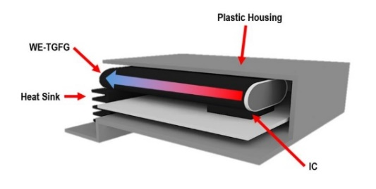  Image source: Würth Elektronik  An application for WE-TGFG: The power loss of the IC component is conducted laterally to a heat sink through the graphite gasket. | 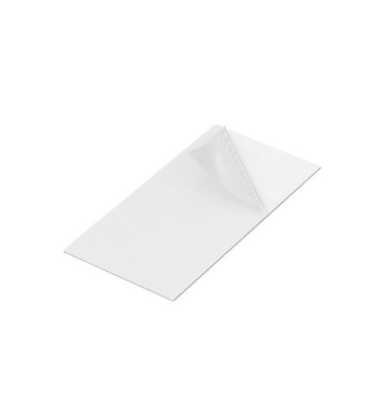  Image source: Würth Elektronik  WE-TGF silicone pads close gaps and allow heat to dissipate.

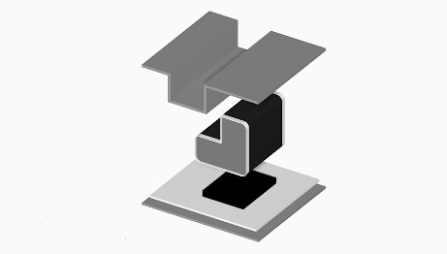
Image source: Würth Elektronik
With custom profiles, the WE-TGFG can interface non-planar contact surfaces

About the Würth Elektronik eiSos Group
Würth Elektronik eiSos Group is a manufacturer of electronic and electromechanical components for the electronics industry and a technology company that spearheads pioneering electronic solutions. Würth Elektronik eiSos is one of the largest European manufacturers of passive components and is active in 50 countries. Production sites in Europe, Asia and North America supply a growing number of customers worldwide.
The product range includes EMC components, inductors, transformers, RF components, varistors, capacitors, resistors, quartz crystals, oscillators, power modules, Wireless Power Transfer, LEDs, sensors, connectors, power supply elements, switches, push-buttons, connection technology, fuse holders and solutions for wireless data transmission.
The unrivaled service orientation of the company is characterized by the availability of all catalog components from stock without minimum order quantity, free samples and extensive support through technical sales staff and selection tools.
Würth Elektronik is part of the Würth Group, the world market leader for assembly and fastening technology. The company employs 7,300 staff and generated sales of 823 million euros in 2020.
Würth Elektronik: more than you expect!
Further information at www.we-online.com

Further information:  Würth Elektronik eiSos GmbH & Co. KG  Sarah Hurst  Max-Eyth-Strasse 1  74638 Waldenburg  Germany  Phone: +49 7942 945-5186  E-mail: sarah.hurst@we-online.de  www.we-online.com | Press contact:  HighTech communications GmbH  Brigitte Basilio  Brunhamstrasse 21  81249 Munich  Germany  Phone: +49 89 500778-20  Telefax: +49 89 500778-77  E-mail: b.basilio@htcm.de  www.htcm.de

