PRESS RELEASE
Würth Elektronik presents slim Bluetooth Low Energy radio module Proteus-e
Even smaller than its brother
Waldenburg (Germany), 16 March 2022 – With the new Proteus-e radio module, Würth Elektronik is continuing its successful Proteus Bluetooth Low Energy series. The focus of the Proteus-e is on basic Bluetooth functionality in order to address price-sensitive applications. The radio module is based on the Bluetooth Low Energy 5.1 standard and includes certificates of conformity for CE, FCC, IC and TELEC. Despite the integrated antenna, the Proteus-e is only 7 x 9 x 2 mm in size, which is a third smaller than the Proteus-III module. For applications with customer own firmware development, the module is offered under the name Ophelia-I, which means as radio module as pure hardware.
Proteus-e und Ophelia-I are based on Nordic Semiconductor's nRF52805 chipset, which includes a 64 MHz Arm Cortex-M4 processor, 192 kB of flash memory and 24 kB of RAM. The maximum output power is 4 dBm, and the maximum data rate is 2 Mbps. In power-saving mode, the module, which was developed for mobile applications, requires only 0.3 µA. With the Proteus-e, connection timing, advertising packets and timing, beacons and UART can be freely configured. Würth Elektronik offers an evaluation board for easy commissioning and testing. With its help, the module can be connected to microcontrollers for application development. Würth Elektronik provides design-in support and offers firmware development services on request. The radio modules and evaluation boards are available from stock with no minimum order quantity.

Available images
The following images can be downloaded from the Internet in printable quality: https://kk.htcm.de/press-releases/wuerth/
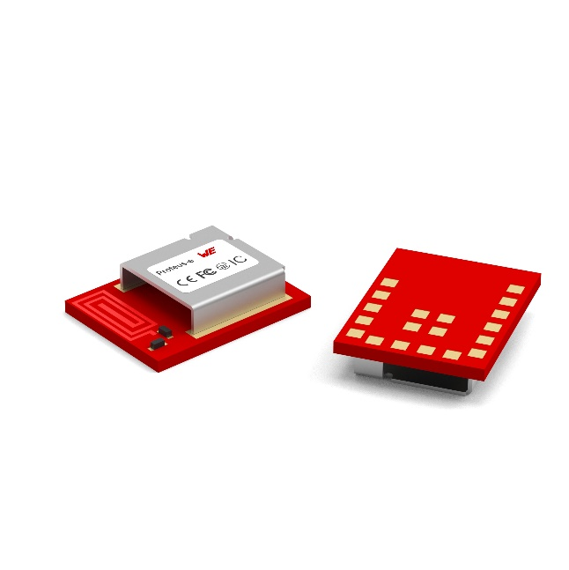
Image source: Würth Elektronik
Despite the integrated antenna, the Proteus-e is only 7 x 9 x 2 mm in size, which is a third smaller than the Proteus-III module.
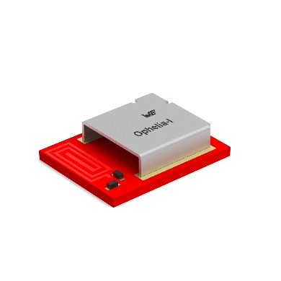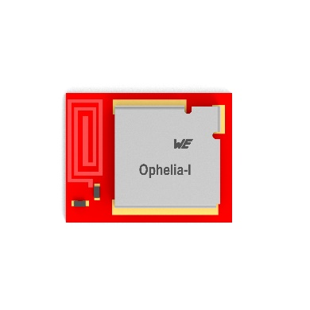
Image source: Würth Elektronik
The miniaturized Proteus-e BLE module is also available without pre-loaded firmware under the name Ophelia-I for customer own applications.

About the Würth Elektronik eiSos Group
Würth Elektronik eiSos Group is a manufacturer of electronic and electromechanical components for the electronics industry and a technology company that spearheads pioneering electronic solutions. Würth Elektronik eiSos is one of the largest European manufacturers of passive components and is active in 50 countries. Production sites in Europe, Asia and North America supply a growing number of customers worldwide.
The product range includes EMC components, inductors, transformers, RF components, varistors, capacitors, resistors, quartz crystals, oscillators, power modules, Wireless Power Transfer, LEDs, sensors, connectors, power supply elements, switches, push-buttons, connection technology, fuse holders and solutions for wireless data transmission.

The unrivaled service orientation of the company is characterized by the availability of all catalog components from stock without minimum order quantity, free samples and extensive support through technical sales staff and selection tools.
Würth Elektronik is part of the Würth Group, the world market leader for assembly and fastening technology. The company employs 8,000 staff and generated sales of 1.09 Billion Euro in 2021.
Würth Elektronik: more than you expect!
Further information at www.we-online.com

Further information:  Würth Elektronik eiSos GmbH & Co. KG  Sarah Hurst  Max-Eyth-Strasse 1  74638 Waldenburg  Germany  Phone: +49 7942 945-5186  E-mail: sarah.hurst@we-online.de  www.we-online.com | Press contact:  HighTech communications GmbH  Brigitte Basilio  Brunhamstrasse 21  81249 Munich  Germany  Phone: +49 89 500778-20  Telefax: +49 89 500778-77  E-mail: b.basilio@htcm.de  www.htcm.de

