PRESS RELEASE

Würth Elektronik publishes its reference book on DC/DC converters
Power Supply Design without EMC Surprises
Waldenburg (Germany), May 16, 2024 – Würth Elektronik launches another reference book for power supply engineers: “DC/DC Converter Handbook – SMPS topologies from an EMC point of view”. It was unveiled at the prestigious power electronics conference APEC 2024 (IEEE Applied Power Electronics Conference and Exposition) in California at the end of February. It is now available in printed form and will also appear as an e-book in May.
The book by the authors – Andreas Nadler, Steffen Schulze, Raphael Specht and Markus Thoss – provides a compact overview of the most important DC/DC converter topologies: buck and boost converters, as well as SEPIC and flyback converters. It contains examples of circuit layouts and tips for selecting storage chokes, capacitors and filter components, as well as for specifying and selecting the suitable components for each topology. EMC interference sources are clearly itemized. Interference spectra are calculated for the four most common switching regulator topologies and the resulting filter design is presented in detail.
Würth Elektronik’s handbook offers straightforward assistance for DC/DC converter designs together with its REDEXPERT online simulation platform. Estimating conducted interference during the design phase helps prevent bad surprises in the EMC lab.
The book can be ordered at www.we-online.com/dcdc-converter-handbook and costs € 14.89.

Reference book “DC/DC Converter Handbook” (English):
SMPS topologies from an EMC point of view, 1st edition, article no. 9999669
ISBN 978-3-89929-454-5 (printed version)
ISBN 978-3-89929-455-2 (e-book version)

Available images
The following images can be downloaded from the Internet in printable quality: https://kk.htcm.de/press-releases/wuerth/
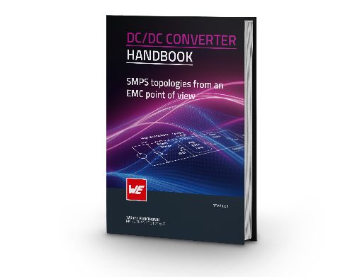

Image source: Würth Elektronik
Würth Elektronik shares expert knowledge: DC/DC Converter Handbook

About the Würth Elektronik eiSos Group
Würth Elektronik eiSos Group is a manufacturer of electronic and electromechanical components for the electronics industry and a technology company that spearheads pioneering electronic solutions. Würth Elektronik eiSos is one of the largest European manufacturers of passive components and is active in 50 countries. Production sites in Europe, Asia and North America supply a growing number of customers worldwide.
The product range includes EMC components, inductors, transformers, RF components, varistors, capacitors, resistors, quartz crystals, oscillators, power modules, Wireless Power Transfer, LEDs, sensors, radio modules, connectors, power supply elements, switches, push-buttons, connection technology, fuse holders and solutions for wireless data transmission. The portfolio is complemented by customized solutions.
The unrivaled service orientation of the company is characterized by the availability of all catalog components from stock without minimum order quantity, free samples and extensive support through technical sales staff and selection tools.

Würth Elektronik is part of the Würth Group, the global market leader in the development, production, and sale of fastening and assembly materials, and employs 7,900 people. In 2023, the Würth Elektronik Group generated sales of 1.24 Billion Euro.
Würth Elektronik: more than you expect!
Further information at www.we-online.com

Further information:  Würth Elektronik eiSos GmbH & Co. KG  Sarah Hurst  Clarita-Bernhard-Strasse 9  81249 Munich  Germany  Phone: +49 7942 945-5186  E-mail: sarah.hurst@we-online.de  www.we-online.com | Press contact:  HighTech communications GmbH  Brigitte Basilio  Brunhamstrasse 21  81249 Munich  Germany  Phone: +49 89 500778-20  E-mail: b.basilio@htcm.de  www.htcm.de

