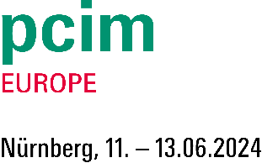
PRESS RELEASE

Würth Elektronik at PCIM
Components and Design Support for Power Electronics
Hall 6, Booth 342
Waldenburg (Germany), May 8, 2024 – Würth Elektronik is exhibiting at PCIM Europe in Nuremberg, June 11-13, 2024. The manufacturer will present electronic and electromechanical components in Hall 6, Booth 342. Many of the products have been specially developed for power electronics in fields such as e-mobility and renewable energies. Product highlights are high-current inductors, high-temperature power inductors, high-voltage storage inductors, WE-TORPFC toroidal PFC chokes, WE-CFWI coupled flat-wire inductors and supercapacitors. Würth Elektronik also pays special attention to gate-drive transformers and current-compensated chokes for network applications. The product presentation is rounded off by electromechanical components like the REDCUBE press-fit contacts and thermal management solutions.
Recent examples of Würth Elektronik’s wide range of inductive components include the WE-XHMI SMT power inductors, with their high current-carrying capacity up to 56 A saturation current, and the WE-MAPI wound metal-alloy power inductors, some of the smallest of their type on the market. Also available are the WE-LHMI shielded SMT power inductors, including a temperature-insensitive version, as well as high-voltage power inductors, such as WE-PD HV and WE-PD2 HV for 400 VDC applications. Würth Elektronik provides reference guides and online tools for selecting suitable components and advises on design questions.
"We are also much more than just a component supplier in the power electronics segment," underlines Alexander Gerfer, CTO of the Würth Elektronik eiSos Group. "We support customers, partners and start-ups in their development work - with free component samples, with the REDEXPERT selection and design tool based on measurement data, with reference designs and with targeted advice from our FAEs in the field."
Würth Elektronik maintains partnerships with IC manufacturers to generate reference designs, including STMicroelectronics and Microchip, who will be joining on the booth.
Charging stations and photovoltaics
Würth Elektronik is expanding its range of applications to improve the turnaround in energy policy. The WE-BMS transformer series for battery management systems, with versions including an operating voltage of 1500 V_{DC}, has recently been expanded. They are intended for use in large stationary energy storage systems for solar and wind parks, or for intermediate storage with high-power charging stations to balance out peak loads. WE-PLC – a transformer for power line communication – is also brand new. Film capacitors specially designed for DC link applications have been available for the last year. The WCAP-FTDB series components can be used in the voltage range from 500 to 1200 V and are characterized by high ripple current capability. This makes them particularly attractive for use in AC/DC and DC/DC converters for charging systems and power electronics in e-mobility or in renewable energy solutions.
Presentations and Students Day
Würth Elektronik is once again participating in the presentation program at PCIM. Jens Kehl, Product Manager in the Power Magnetics division, will speak on “Challenges and Solutions in the Specification of an Operating Voltage for Metal Alloy Powder Based Inductors” in Hall 7, Booth 7-743 on the Technology Stage on Tuesday, June 11 at 3:00 pm.
Heinz Zenkner will also hold a seminar on “EMC-Proof Circuit Design and the Scare of Inductances” at the Arvena Park Hotel on June 9 from 2:00 pm.
Würth Elektronik will be taking part in Students Day on the last day of the show, June 13, organized by the ECPE (European Center for Power Electronics).

Available images
The following images can be downloaded from the Internet in printable quality: https://kk.htcm.de/press-releases/wuerth/
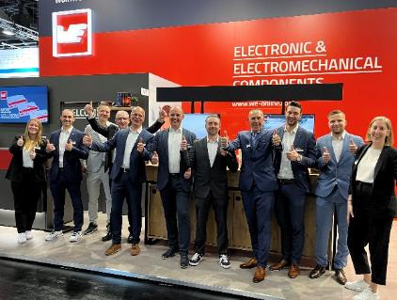  Image source: Würth Elektronik  The Würth Elektronik booth team is looking forward to welcoming PCIM visitors. | 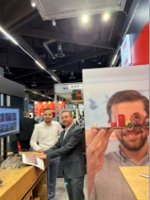  Image source: Würth Elektronik  Components suitable for every application from Würth Elektronik

About the Würth Elektronik eiSos Group
Würth Elektronik eiSos Group is a manufacturer of electronic and electromechanical components for the electronics industry and a technology company that spearheads pioneering electronic solutions. Würth Elektronik eiSos is one of the largest European manufacturers of passive components and is active in 50 countries. Production sites in Europe, Asia and North America supply a growing number of customers worldwide.
The product range includes EMC components, inductors, transformers, RF components, varistors, capacitors, resistors, quartz crystals, oscillators, power modules, Wireless Power Transfer, LEDs, sensors, radio modules, connectors, power supply elements, switches, push-buttons, connection technology, fuse holders and solutions for wireless data transmission. The portfolio is complemented by customized solutions.
The unrivaled service orientation of the company is characterized by the availability of all catalog components from stock without minimum order quantity, free samples and extensive support through technical sales staff and selection tools.
Würth Elektronik is part of the Würth Group, the global market leader in the development, production, and sale of fastening and assembly materials, and employs 7,900 people. In 2023, the Würth Elektronik Group generated sales of 1.24 Billion Euro.
Würth Elektronik: more than you expect!
Further information at www.we-online.com

Further information:  Würth Elektronik eiSos GmbH & Co. KG  Sarah Hurst  Clarita-Bernhard-Strasse 9  81249 Munich  Germany  Phone: +49 7942 945-5186  E-mail: sarah.hurst@we-online.de  www.we-online.com | Press contact:  HighTech communications GmbH  Brigitte Basilio  Brunhamstrasse 21  81249 Munich  Germany  Phone: +49 89 500778-20  E-mail: b.basilio@htcm.de  www.htcm.de

