PRESS RELEASE
Würth Elektronik presents its revised “Trilogy of Wireless Power Transfer”
Reference Book on Wireless Power Transmission Expanded
Waldenburg (Germany) June 12, 2024 – The reference book “Trilogy of Wireless Power Transfer” by Würth Elektronik is now available in a revised second edition. The manufacturer with the largest selection of wireless power coils on the market shares its expertise in wireless power transmission. The practice-oriented reference book consists of three parts: Basic Principles of Wireless Power Transmission, Wireless Power Transfer Systems and Applications. It costs 19 euros and is available from Würth Elektronik and in bookstores.
The first part of the reference book has been completely revised and explains the physical principles of the various methods of contactless power transmission. The key standards and developments of the technology are also discussed. The second part describes the wireless power transfer systems and the different topologies of wireless power transmission. In the same chapter, the correct selection of the required transmitter and receiver coils to increase efficiency, and also the available transistors, are discussed. The practice-oriented third part is supplemented with an innovative application: NFC communication together with wireless power transmission. An overview of EMI-related topics rounds off the compilation of application examples in the practice section. The authors of the “Trilogy of Wireless Power Transfer” are Cem Som, Vice President Europe at Wurth Electronics Midcom Inc. and Dr. Michael de Rooij, Vice President Applications Engineering at Efficient Power Conversion Corporation, Inc.

Available images
The following images can be downloaded from the Internet in printable quality: https://kk.htcm.de/press-releases/wuerth/

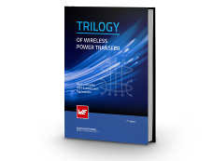  Image source: Würth Elektronik  Revised new edition: “Trilogy of Wireless Power Transfer” by Würth Elektronik | 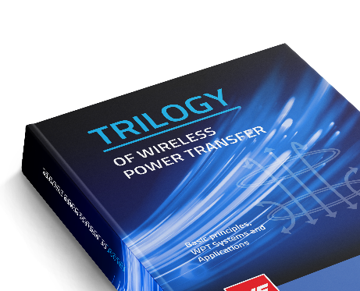  Image source: Würth Elektronik  Reference book “Trilogy of Wireless Power Transfer”: Expertise for wireless power transmission

About the Würth Elektronik eiSos Group
Würth Elektronik eiSos Group is a manufacturer of electronic and electromechanical components for the electronics industry and a technology company that spearheads pioneering electronic solutions. Würth Elektronik eiSos is one of the largest European manufacturers of passive components and is active in 50 countries. Production sites in Europe, Asia and North America supply a growing number of customers worldwide.
The product range includes EMC components, inductors, transformers, RF components, varistors, capacitors, resistors, quartz crystals, oscillators, power modules, Wireless Power Transfer, LEDs, sensors, radio modules, connectors, power supply elements, switches, push-buttons, connection technology, fuse holders and solutions for wireless data transmission. The portfolio is complemented by customized solutions.
The unrivaled service orientation of the company is characterized by the availability of all catalog components from stock without minimum order quantity, free samples and extensive support through technical sales staff and selection tools.
Würth Elektronik is part of the Würth Group, the global market leader in the development, production, and sale of fastening and assembly materials, and employs 7,900 people. In 2023, the Würth Elektronik Group generated sales of 1.24 Billion Euro.
Würth Elektronik: more than you expect!
Further information at www.we-online.com

Further information:  Würth Elektronik eiSos GmbH & Co. KG  Sarah Hurst  Clarita-Bernhard-Strasse 9  81249 Munich  Germany  Phone: +49 7942 945-5186  E-mail: sarah.hurst@we-online.de  www.we-online.com | Press contact:  HighTech communications GmbH  Brigitte Basilio  Brunhamstrasse 21  81249 Munich  Germany  Phone: +49 89 500778-20  E-mail: b.basilio@htcm.de  www.htcm.de

