PRESS RELEASE

Würth Elektronik expands its optocoupler series with Opto-TRIACs
Phase Control with Galvanic Isolation
Waldenburg (Germany), July 4, 2024 – Würth Elektronik now offers a solution for phase control of AC loads, the new WL-OCTR optocouplers, a safe alternative to mechanical relays. The TRIAC optocouplers are particularly suitable for use in lamp dimming functions and AC motor drivers in household appliances. They can also be used as drivers for high-current TRIACs.
The Würth Elektronik TRIAC optocouplers are available with and without a zero-cross function to shift the TRIAC switch-on point. The portfolio includes both THT and SMT designs in DIP4, DIP6 and SOP4 packages and offers trigger currents of 5, 10 or 15 mA. A CTI (Comparative Tracking Index) value (describing leakage current stability) of over 500 and insulation voltages of 3750 or 5000 V for the THT and SMT designs makes the optocouplers ideally suited for circuit protection. Like all optocouplers from Würth Elektronik, the newest addition to the optocoupler portfolio is certified to all necessary standards: UL1577, EN IEC 60747-5-5 VDE 0884-5, CQC GB 4941.1-2022.
The Würth Elektronik TRIAC optocouplers are now available from stock and free samples are available for developers.

Available images
The following images can be downloaded from the Internet in printable quality: https://kk.htcm.de/press-releases/wuerth/

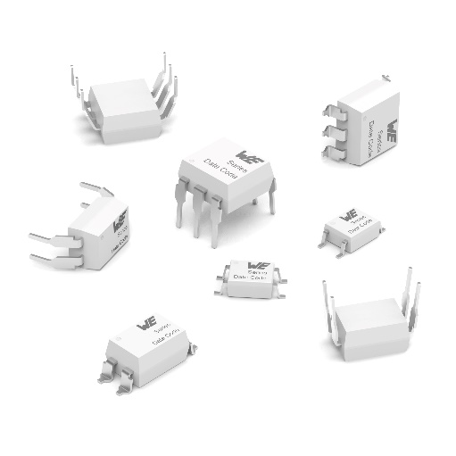Image source: Würth Elektronik
WL-OCTR TRIAC optocouplers

About the Würth Elektronik eiSos Group
Würth Elektronik eiSos Group is a manufacturer of electronic and electromechanical components for the electronics industry and a technology company that spearheads pioneering electronic solutions. Würth Elektronik eiSos is one of the largest European manufacturers of passive components and is active in 50 countries. Production sites in Europe, Asia and North America supply a growing number of customers worldwide.
The product range includes EMC components, inductors, transformers, RF components, varistors, capacitors, resistors, quartz crystals, oscillators, power modules, Wireless Power Transfer, LEDs, sensors, radio modules, connectors, power supply elements, switches, push-buttons, connection technology, fuse holders and solutions for wireless data transmission. The portfolio is complemented by customized solutions.
The unrivaled service orientation of the company is characterized by the availability of all catalog components from stock without minimum order quantity, free samples and extensive support through technical sales staff and selection tools.
Würth Elektronik is part of the Würth Group, the global market leader in the development, production, and sale of fastening and assembly materials, and employs 7,900 people. In 2023, the Würth Elektronik Group generated sales of 1.24 Billion Euro.

Würth Elektronik: more than you expect!
Further information at www.we-online.com

Further information:  Würth Elektronik eiSos GmbH & Co. KG  Sarah Hurst  Clarita-Bernhard-Strasse 9  81249 Munich  Germany  Phone: +49 7942 945-5186  E-mail: sarah.hurst@we-online.de  www.we-online.com | Press contact:  HighTech communications GmbH  Brigitte Basilio  Brunhamstrasse 21  81249 Munich  Germany  Phone: +49 89 500778-20  E-mail: b.basilio@htcm.de  www.htcm.de

