PRESS RELEASE

Würth Elektronik at Oscilloscope Days 2024
Useful Information for Daily Measurement and Testing Practice
Waldenburg (Germany), March 20, 2024 – Würth Elektronik is participating at Rohde & Schwarz Oscilloscope Days on April 17 and 18, 2024. The virtual event will cover various topics through webcasts that addresses challenges encountered by electronics engineers alongside test and measurement equipment like oscilloscopes.
Three presenters from Würth Elektronik eiSos will take part in the popular online conference. On April 17 at 10:15 am, Field Application Engineers Robert Schillinger and Mohamed Al-Alami will talk about “Loop compensation - Buck Converter Design and Measurements,” followed by their presentation “Design for EMC - Boost converter Design and Measurements.” at 11:30 am.
Adrian Stirn, Technical Lead EMC Laboratory at Würth Elektronik eiSos, will present on “The Gigabit Ethernet Interface under EMC Aspects” on April 18 at 11:15 am in the “Signal Integrity Debugging” session.
Alexander Gerfer, CTO of the Würth Elektronik eiSos Group, holds the event in very high regard: “The application-oriented content of all sessions is sure to provide high added value to the engineers taking part. That’s why we’ve supported Rohde & Schwarz as an event partner for several years now.”

Registration for the event at: https://www.rohde-schwarz.com/de/knowledge-center/webinars/webinar-oscilloscope-days-registration_257054.html

Available images
The following images can be downloaded from the Internet in printable quality: https://kk.htcm.de/press-releases/wuerth/

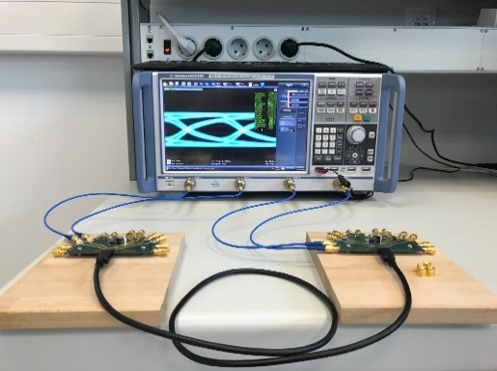Image source: Würth Elektronik
Oscilloscope with test setup

About the Würth Elektronik eiSos Group
Würth Elektronik eiSos Group is a manufacturer of electronic and electromechanical components for the electronics industry and a technology company that spearheads pioneering electronic solutions. Würth Elektronik eiSos is one of the largest European manufacturers of passive components and is active in 50 countries. Production sites in Europe, Asia and North America supply a growing number of customers worldwide.
The product range includes EMC components, inductors, transformers, RF components, varistors, capacitors, resistors, quartz crystals, oscillators, power modules, Wireless Power Transfer, LEDs, sensors, radio modules, connectors, power supply elements, switches, push-buttons, connection technology, fuse holders and solutions for wireless data transmission. The portfolio is complemented by customized solutions.
The unrivaled service orientation of the company is characterized by the availability of all catalog components from stock without minimum order quantity, free samples and extensive support through technical sales staff and selection tools.
Würth Elektronik is part of the Würth Group, the global market leader in the development, production, and sale of fastening and assembly materials, and employs 7,900 people. In 2023, the Würth Elektronik Group generated sales of 1.24 Billion Euro.
Würth Elektronik: more than you expect!
Further information at www.we-online.com

Further information:  Würth Elektronik eiSos GmbH & Co. KG  Sarah Hurst  Clarita-Bernhard-Strasse 9  81249 Munich  Germany  Phone: +49 7942 945-5186  E-mail: sarah.hurst@we-online.de  www.we-online.com | Press contact:  HighTech communications GmbH  Brigitte Basilio  Brunhamstrasse 21  81249 Munich  Germany  Phone: +49 89 500778-20  E-mail: b.basilio@htcm.de  www.htcm.de

