PRESS RELEASE

Würth Elektronik expands its range of digital isolators
2-Channel Digital Isolators now with 5000 V Isolation Voltage
Waldenburg (Germany), June 27, 2024 – Würth Elektronik is expanding its portfolio of digital isolators with a two-channel version in SOIC 8WB package (5.85 x 11.5 x 2.8 mm). The new design boasts an isolation voltage of 5 kV_{RMS}. This is particularly important for electronic devices operating in environments exposed to high voltages and EMC interference which need 2-channel digital isolators with high isolation voltage. The isolators are ideally suited for high-speed applications up to a data rate of 150 Mbps and are characterized by their high common mode transient immunity (CMTI) to system noise of ±150 kV/µs.
SMT-mountable digital isolators are used for galvanic isolation in transmitting digital signals. This ensures reliable data transmission without distortion or errors to protect people or sensitive circuits from high voltage. The WPME-CDIS (Capacitive Digital Isolator Standard) series of isolators with UL 1577 approval can be used, for example, in test and measurement systems, battery management systems, solar inverters, industrial switching power supplies and motor controllers as well as for isolating communication buses. Alongside the new components, there are already various two-channel and four-channel configurations with high or low default output. With its designation WPME-CDIP (Capacitive Digital Isolator Powered), Würth Elektronik also offers capacitive digital isolators with integrated DC/DC converter.
Free samples of all the digital isolators can be ordered from Würth Elektronik.

Available images
The following images can be downloaded from the Internet in printable quality: https://kk.htcm.de/press-releases/wuerth/

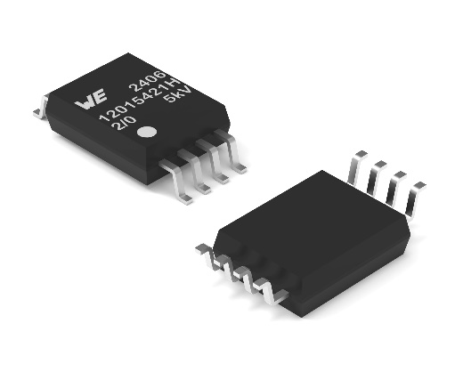
Image source: Würth Elektronik
The WPME-CDIS series digital isolators are now also available in a SOIC-8WB version with an isolation voltage of 5000 V_{RMS}.

About the Würth Elektronik eiSos Group
Würth Elektronik eiSos Group is a manufacturer of electronic and electromechanical components for the electronics industry and a technology company that spearheads pioneering electronic solutions. Würth Elektronik eiSos is one of the largest European manufacturers of passive components and is active in 50 countries. Production sites in Europe, Asia and North America supply a growing number of customers worldwide.
The product range includes EMC components, inductors, transformers, RF components, varistors, capacitors, resistors, quartz crystals, oscillators, power modules, Wireless Power Transfer, LEDs, sensors, radio modules, connectors, power supply elements, switches, push-buttons, connection technology, fuse holders and solutions for wireless data transmission. The portfolio is complemented by customized solutions.
The unrivaled service orientation of the company is characterized by the availability of all catalog components from stock without minimum order quantity, free samples and extensive support through technical sales staff and selection tools.
Würth Elektronik is part of the Würth Group, the global market leader in the development, production, and sale of fastening and assembly materials, and employs 7,900 people. In 2023, the Würth Elektronik Group generated sales of 1.24 Billion Euro.

Würth Elektronik: more than you expect!
Further information at www.we-online.com

Further information:  Würth Elektronik eiSos GmbH & Co. KG  Sarah Hurst  Clarita-Bernhard-Strasse 9  81249 Munich  Germany  Phone: +49 7942 945-5186  E-mail: sarah.hurst@we-online.de  www.we-online.com | Press contact:  HighTech communications GmbH  Brigitte Basilio  Brunhamstrasse 21  81249 Munich  Germany  Phone: +49 89 500778-20  E-mail: b.basilio@htcm.de  www.htcm.de

