PRESS RELEASE
“Germany’s most innovative companies”: Maximum patent potential for the Würth Elektronik Group
Patently an Innovative Company
Waldenburg (Germany), May 2, 2024 – In the innovation ranking from Capital, the acclaimed German business magazine, Würth Elektronik once again landed a prestigious four-star ranking in the Electronics & Electrical Engineering, Automation and Measurement Technology category. Especially gratifying, the renowned manufacturer of electronic and electromechanical components, printed circuit boards, and intelligent power and control systems, also picked up a top rating in the important sector of ‘patent relevance’.
Capital has selected the company as "Germany’s Most Innovative Companies” for the fifth time now. The ranking encompasses 20 sectors and industries, from the automotive industry and the chemical sector, to energy and the environment.
In the survey, 3,566 innovation experts had the chance to select the leading companies in their industries from a total of 1,902 candidates. Würth Elektronik was among 465 innovative organizations to again be considered this year, being awarded four stars.
High patent relevance
Just like last year, Würth Elektronik again earned the highest score for patent relevance in 2024 with two points. This is based on Technology Relevance™, which evaluates forward citations: The more often a patent is the source for further innovations, the higher the index.
Corporate philosophy once again endorsed
The consistently high rating for patent relevance once again endorses Würth Elektronik Group's innovation and service strategy. The company sees itself not only as a dedicated producer and supplier, but also a supporter of customers and start-ups with knowledge transfer. Würth Elektronik Group developments serve as the fundamentals that make innovations possible every day in many industries. This strategy forms the bedrock for the company's international success in line with its mission, “Creating Together.”

Available images
The following images can be downloaded from the Internet in printable quality: https://kk.htcm.de/press-releases/wuerth/
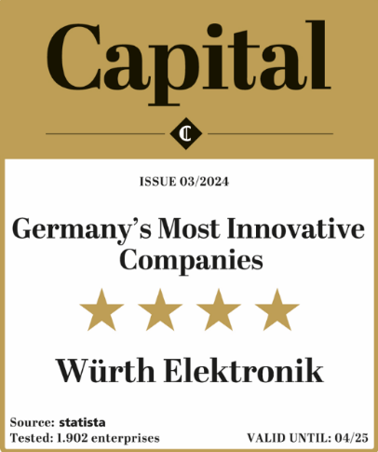Image source: statista  Acclaimed for the fifth time: Würth Elektronik earns a four-star rating in "Germany's most innovative companies" survey | 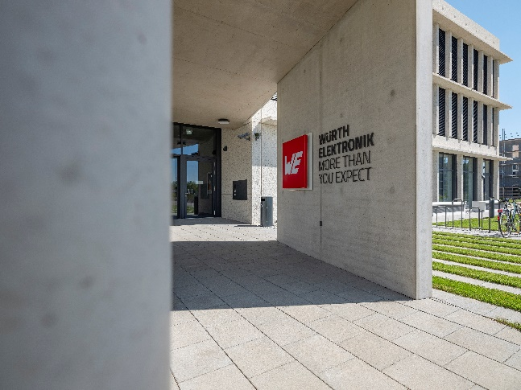  Image source: Würth Elektronik  Creating Together: In the contemporary New Work environment, Würth Elektronik develops patents to drive innovation forward.

About the Würth Elektronik group of companies
The Würth Elektronik group of companies, founded in Niedernhall, Baden-Wuerttemberg, Germany, has about 7,900 employees worldwide and generated global sales of 1.24 Billion Euro in 2023.
With over 23 production locations worldwide, Würth Elektronik is one of the most successful companies of the Würth Group.
Würth Elektronik operates internationally with its three company areas in various markets:
- Electronic & electromechanical components (Headquarters: Waldenburg)
Würth Elektronik eiSos (electronic and electromechanical components) is one of Europe's biggest manufacturers of electronic & electromechanical components. More than 700 sales representatives worldwide make up a direct sales network that is unique for the electronics market. The customer is offered excellent design-in support on-site from the manufacturer. The production plants in Germany, Czech Republic, Bulgaria, USA, Mexico, Taiwan and China guarantee high availability on all markets. All catalog products are available from stock and samples are free of charge.
- PCBs (Headquarters: Niedernhall)
Founded in 1971, Würth Elektronik Circuit Board Technology is today Europe's leading PCB manufacturer and, thanks to the comprehensive portfolio, a reliable partner for both individual entrepreneurs and large corporations. Whether basic or high-end technologies, customer-specific requirements are met from the initial idea for a design to the production of prototypes on the online shop and finally, manufacturing of medium and large volumes in Germany or Asia.
- Intelligent Power & Control Systems (Headquarters: Niedernhall-Waldzimmern)
As a specialist for the development and production of electronic and electromechanical system solutions, such as central electronics, Würth Elektronik ICS (Intelligent Power & Control Systems) is a longtime partner for many commercial vehicles. Professional project management accompanies business partners from the product idea through to series maturity.

Further info at www.we-online.com

More information:  Würth Elektronik eiSos GmbH & Co. KG  Sarah Hurst  Max-Eyth-Strasse 1  74638 Waldenburg  Germany  Phone: +49 7942 945-5186  E-mail: sarah.hurst@we-online.de  www.we-online.com | Press contact:  HighTech communications GmbH  Brigitte Basilio  Brunhamstrasse 21  81249 Munich  Germany  Phone: +49 89 500778-20  Telefax: +49 89 500778-77  E-mail: b.basilio@htcm.de  www.htcm.de

