PRESS RELEASE

Würth Elektronik defines an electrical property for molded inductors
New Testing Procedure for Determining Dielectric Strength
Waldenburg (Germany), July 17, 2024 – Würth Elektronik has developed a new testing procedure for determining the maximum operating voltage of molded inductors. The manufacturer of electronic and electromechanical components introduces developers to the electrical property of dielectric strength and what happens if it is exceeded in an application which is described in Application Note 126 (www.we-online.com/ANP126). The molded inductors from the Power Magnetics product portfolio (e. g., WE-MAPI, WE-XHMI, WE-LHMI) are now successively supplemented with the value of the maximum operating voltage V_{op} as a new parameter in the specifications.
Based on the new testing procedure, Würth Elektronik defines the maximum operating voltage V_{op} in its data sheets. This represents the voltage at which an inductor can be operated continuously in the application without impairing performance, risking damage or overheating the inductor. The operating voltage is therefore a limit value for the input voltage, up to which the inductor can be used reliably in an application without irreversible damage.
The test concept examines the behavior of inductors up to their voltage limits under realistic conditions in a DC-DC full-bridge converter (voltage transients of up to 60 V/ns and frequencies of up to 2 MHz). The approximate voltage limit is firstly evaluated using a short-term test. The operating voltage is then defined on this basis and verified in a long-term test.
Background
Thanks to steady technological advancement in the semiconductor industry, today’s MOSFETs can now achieve high current densities and short switching times. For this reason, the question of the dielectric strength of coils has become increasingly important in recent years when it comes to selecting the appropriate inductor.
What’s more: Continuous optimization of the production process and the material composition of molded inductors enable high permeability of the ferrite material to achieve the highest possible inductance values in the smallest possible package space. The power density per volume can therefore be raised continuously.
This entailed a steady increase in the proportion of iron powder or iron alloys relative to the insulation of the binder, resulting in the distance between individual grains becoming progressively smaller. If the insulation barrier between the individual metal particles is not high enough for the voltage applied in the application, a conductive path is created through the core material, caused by arcing between the individual metal particles. It may be observed in the application that the profile of the ripple current changes. Schematically, there is now a resistor parallel to the inductor.
The consequences: Self-heating of the coil rises dramatically due to the rising losses. These additional losses considerably reduce the inductor’s efficiency. The advantage of a DC/DC converter – to transmit voltage levels with high efficiency – is lost.

Available images
The following images can be downloaded from the Internet in printable quality: https://kk.htcm.de/press-releases/wuerth/
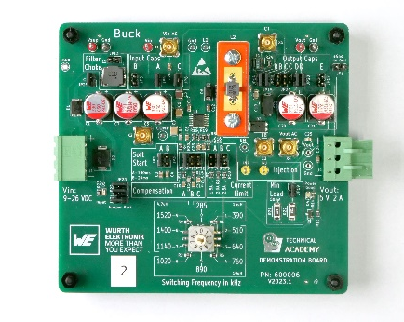  Image source: Würth Elektronik  Example application: DC/DC converter | 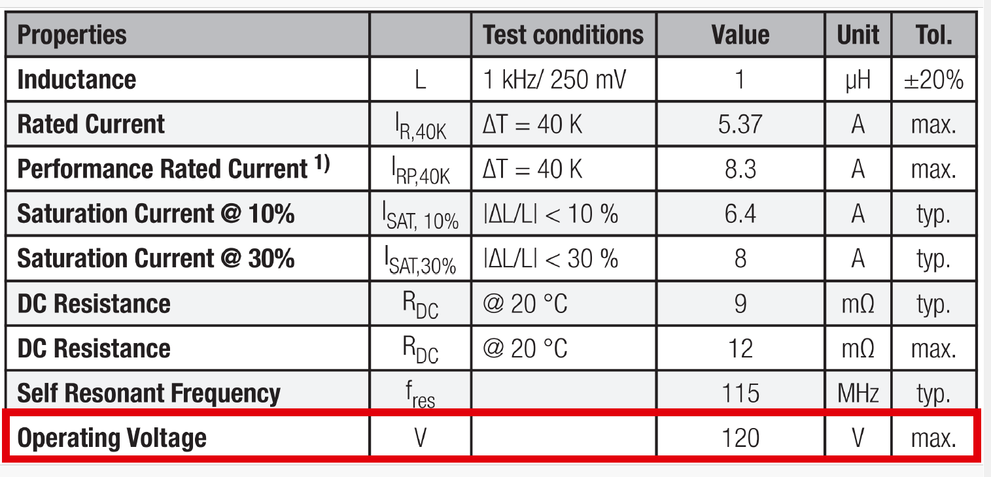Image source: Würth Elektronik  The new product characteristic in the data sheet clearly indicates the maximum operating voltage of the inductor in the application.

About the Würth Elektronik eiSos Group
Würth Elektronik eiSos Group is a manufacturer of electronic and electromechanical components for the electronics industry and a technology company that spearheads pioneering electronic solutions. Würth Elektronik eiSos is one of the largest European manufacturers of passive components and is active in 50 countries. Production sites in Europe, Asia and North America supply a growing number of customers worldwide.
The product range includes EMC components, inductors, transformers, RF components, varistors, capacitors, resistors, quartz crystals, oscillators, power modules, Wireless Power Transfer, LEDs, sensors, radio modules, connectors, power supply elements, switches, push-buttons, connection technology, fuse holders and solutions for wireless data transmission. The portfolio is complemented by customized solutions.
The unrivaled service orientation of the company is characterized by the availability of all catalog components from stock without minimum order quantity, free samples and extensive support through technical sales staff and selection tools.
Würth Elektronik is part of the Würth Group, the global market leader in the development, production, and sale of fastening and assembly materials, and employs 7,900 people. In 2023, the Würth Elektronik Group generated sales of 1.24 Billion Euro.
Würth Elektronik: more than you expect!
Further information at www.we-online.com

Further information:  Würth Elektronik eiSos GmbH & Co. KG  Sarah Hurst  Clarita-Bernhard-Strasse 9  81249 Munich  Germany  Phone: +49 7942 945-5186  E-mail: sarah.hurst@we-online.de  www.we-online.com | Press contact:  HighTech communications GmbH  Brigitte Basilio  Brunhamstrasse 21  81249 Munich  Germany  Phone: +49 89 500778-20  E-mail: b.basilio@htcm.de  www.htcm.de

