PRESS RELEASE

Würth Elektronik extends its series of wire-wound ferrites
One Component, Two Applications
Waldenburg (Germany), August 7, 2024 – Würth Elektronik now offers its WE-RFI inductors in sizes 0402 and 0603, which can be used as inductors for HF applications or as ferrites for interference suppression. Here the manufacturer responds to increasing miniaturization and complements the existing sizes 0805 and 1008. The components are suitable as low-pass filters (for filtering high-frequency noise), data line filters, supply voltage decoupling, low-frequency radio applications, and RFID.
As wire-wound ferrites, the WE-RFI inductors attain higher impedances than normal ferrites, even at high frequencies, and over a wider bandwidth. Unlike multilayer ferrites, they show no DC bias behavior.
As HF inductors, they offer high inductance values from 20 nH up to 47 µH. They are characterized by low R_{DC} and consequently a high rated current of up to 1.91 A at ΔT = 40 K. A design kit is available for this component group, which Würth Elektronik will always replenish free of charge, so developers always have inductances of different values to hand.

Available images
The following images can be downloaded from the Internet in printable quality: https://kk.htcm.de/press-releases/wuerth/
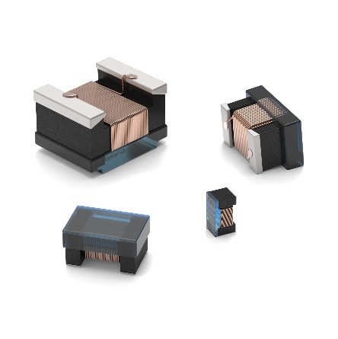
WE-RFI can be used as an inductor for HF applications or as a ferrite for interference suppression.
Image source: Würth Elektronik

About the Würth Elektronik eiSos Group
Würth Elektronik eiSos Group is a manufacturer of electronic and electromechanical components for the electronics industry and a technology company that spearheads pioneering electronic solutions. Würth Elektronik eiSos is one of the largest European manufacturers of passive components and is active in 50 countries. Production sites in Europe, Asia and North America supply a growing number of customers worldwide.
The product range includes EMC components, inductors, transformers, RF components, varistors, capacitors, resistors, quartz crystals, oscillators, power modules, Wireless Power Transfer, LEDs, sensors, radio modules, connectors, power supply elements, switches, push-buttons, connection technology, fuse holders and solutions for wireless data transmission. The portfolio is complemented by customized solutions.
The unrivaled service orientation of the company is characterized by the availability of all catalog components from stock without minimum order quantity, free samples and extensive support through technical sales staff and selection tools.
Würth Elektronik is part of the Würth Group, the global market leader in the development, production, and sale of fastening and assembly materials, and employs 7,900 people. In 2023, the Würth Elektronik Group generated sales of 1.24 Billion Euro.
Würth Elektronik: more than you expect!
Further information at www.we-online.com

Further information:  Würth Elektronik eiSos GmbH & Co. KG  Sarah Hurst  Clarita-Bernhard-Strasse 9  81249 Munich  Germany  Phone: +49 7942 945-5186  E-mail: sarah.hurst@we-online.de  www.we-online.com | Press contact:  HighTech communications GmbH  Brigitte Basilio  Brunhamstrasse 21  81249 Munich  Germany  Phone: +49 89 500778-20  E-mail: b.basilio@htcm.de  www.htcm.de

