PRESS RELEASE

Würth Elektronik presents its optical sensors for object recognition
Reflective Infrared Sensor
Waldenburg (Germany), October 10, 2024 – Würth Elektronik launches a new program for optical sensors (product code: WL-OSEN) with the first two components. These compact modules contain both emitters and detectors for infrared light at 940 nm wavelength. A special feature: The Würth Elektronik sensors filter out visible light up to 800 nm, rather than just up to 700 nm as is the case for many other sensors of this type available on the market. So they are less susceptible to errors occurring under artificial lighting.
The sensor in the 4-SMD gullwing standard housing measures 2.7 × 3.4 × 1.5 mm without contacts. It is designed for close range, typically at a distance of 1 mm and serves as a simple touch switch, for example under a glass plate. The second compact SMD sensor, with its lower beam angle and measuring 2.0 × 1.6 × 0.75 mm, can detect at a greater distance up to 10 mm, making it more robust against crosstalk than a simple touch switch, e.g., when used under glass. Both sensors offer an analog output and low energy consumption. Possible applications include optical encoders, switches and interlocks, as well as object detection or touch applications.
The Würth Elektronik infrared sensors are now available from stock without a minimum order quantity. Developers can receive free samples.

Available images
The following images can be downloaded from the Internet in printable quality: https://kk.htcm.de/press-releases/wuerth/
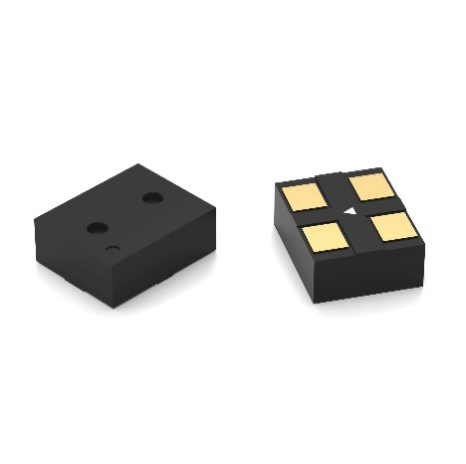  Image source: Würth Elektronik  WL-OSEN – the compact infrared sensors – are the founding members of a new product group: optical sensors from Würth Elektronik. The particularly compact version measures just 2.0 × 1.6 × 0.75 mm. | 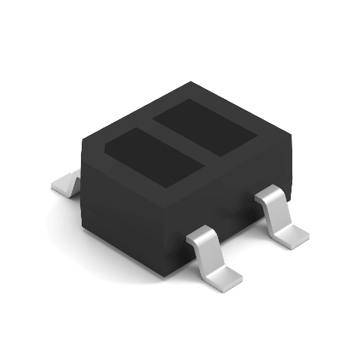  Image source: Würth Elektronik  The WL-OSEN optical sensor in its standard housing is designed for the immediate near field with a range of a few millimeters.

About the Würth Elektronik eiSos Group
Würth Elektronik eiSos Group is a manufacturer of electronic and electromechanical components for the electronics industry and a technology company that spearheads pioneering electronic solutions. Würth Elektronik eiSos is one of the largest European manufacturers of passive components and is active in 50 countries. Production sites in Europe, Asia and North America supply a growing number of customers worldwide.
The product range includes EMC components, inductors, transformers, RF components, varistors, capacitors, resistors, quartz crystals, oscillators, power modules, Wireless Power Transfer, LEDs, sensors, radio modules, connectors, power supply elements, switches, push-buttons, connection technology, fuse holders and solutions for wireless data transmission. The portfolio is complemented by customized solutions.
The unrivaled service orientation of the company is characterized by the availability of all catalog components from stock without minimum order quantity, free samples and extensive support through technical sales staff and selection tools.
Würth Elektronik is part of the Würth Group, the global market leader in the development, production, and sale of fastening and assembly materials, and employs 7,900 people. In 2023, the Würth Elektronik Group generated sales of 1.24 Billion Euro.
Würth Elektronik: more than you expect!
Further information at www.we-online.com

Further information:  Würth Elektronik eiSos GmbH & Co. KG  Sarah Hurst  Clarita-Bernhard-Strasse 9  81249 Munich  Germany  Phone: +49 7942 945-5186  E-mail: sarah.hurst@we-online.de  www.we-online.com | Press contact:  HighTech communications GmbH  Brigitte Basilio  Brunhamstrasse 21  81249 Munich  Germany  Phone: +49 89 500778-20  E-mail: b.basilio@htcm.de  www.htcm.de

