PRESS RELEASE

Würth Elektronik offers its radio module for LoRaWAN® communication
Power-saving Module with Long Range
Waldenburg (Germany), November 19, 2024 – Würth Elektronik launches Daphnis-I on the market – a slim, ultra-low power consumption and long range radio module for IoT applications. The transceiver, based on the STM32WLE5CCU6 chip, works with the LoRaWAN® (Long Range Wide Area Network) 1.0.4 protocol. This IoT wireless protocol in the EU868 frequency band allows communication with devices more than ten kilometers away from the gateway. Measuring just 15 × 16 × 3 mm, the Daphnis-I module also fits into size constraints IoT applications. Daphnis-I stands out with its remarkably low power consumption of just 63.9 nA in sleep mode, making it the perfect fit for battery-powered IoT applications. Würth Elektronik offers application developers a tailored evaluation kit, and Smart Commander, a convenient management software with GUI.
Daphnis-I supports LoRaWAN® class A, B and C, which means that the module can receive data in response to its transmissions, either time-controlled or with a permanently open download-receive window. The module is controlled via a UART interface using an easy-to-use AT command set. The Daphnis-I can register to network (activation) with either OTAA or ABP method of activation. For connecting the antenna, there is a choice between the UMRF connector and the RF pin. The output power is 13.4 dBm.
For decentralized IoT applications
The application options vary widely: IoT solutions for smart homes and smart cities, crop and livestock monitoring in agriculture, infrastructure monitoring, security systems, logistics and transportation management, or smart factory applications and Industry 4.0. By optimizing the wireless module to minimize its energy requirement, even battery-operated devices with low maintenance can be designed.
The Daphnis-I wireless modules are now available from stock without minimum order quantities.

Available images
The following images can be downloaded from the Internet in printable quality: https://kk.htcm.de/press-releases/wuerth/
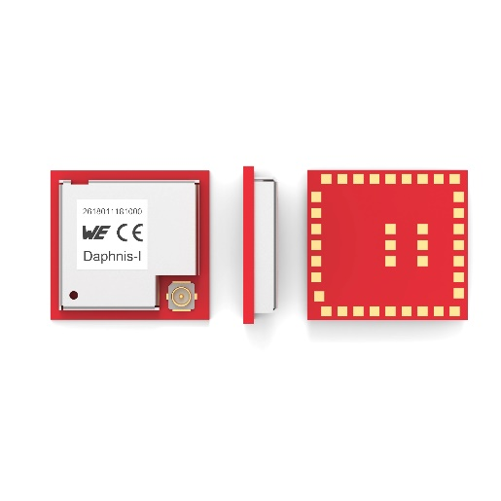
Image source: Würth Elektronik
Takes up little space and draws low current: The Daphnis-I IoT wireless module from Würth Elektronik

About the Würth Elektronik eiSos Group
Würth Elektronik eiSos Group is a manufacturer of electronic and electromechanical components for the electronics industry and a technology company that spearheads pioneering electronic solutions. Würth Elektronik eiSos is one of the largest European manufacturers of passive components and is active in 50 countries. Production sites in Europe, Asia and North America supply a growing number of customers worldwide.
The product range includes EMC components, inductors, transformers, RF components, varistors, capacitors, resistors, quartz crystals, oscillators, power modules, Wireless Power Transfer, LEDs, sensors, radio modules, connectors, power supply elements, switches, push-buttons, connection technology, fuse holders and solutions for wireless data transmission. The portfolio is complemented by customized solutions.
The unrivaled service orientation of the company is characterized by the availability of all catalog components from stock without minimum order quantity, free samples and extensive support through technical sales staff and selection tools.
Würth Elektronik is part of the Würth Group, the global market leader in the development, production, and sale of fastening and assembly materials, and employs 7,900 people. In 2023, the Würth Elektronik Group generated sales of 1.24 Billion Euro.

Würth Elektronik: more than you expect!
Further information at www.we-online.com

Further information:  Würth Elektronik eiSos GmbH & Co. KG  Sarah Hurst  Clarita-Bernhard-Strasse 9  81249 Munich  Germany  Phone: +49 7942 945-5186  E-mail: sarah.hurst@we-online.de  www.we-online.com | Press contact:  HighTech communications GmbH  Brigitte Basilio  Brunhamstrasse 21  81249 Munich  Germany  Phone: +49 89 500778-20  E-mail: b.basilio@htcm.de  www.htcm.de

