PRESS RELEASE

Würth Elektronik presents its WE-MXGI series power inductors for DC/DC converters
Lowest Resistance, Lowest Losses
Waldenburg (Germany), July 10, 2024 – Würth Elektronik offers its WE-MXGI – a power inductor with unprecedented properties. Extremely low core losses, combined with the lowest winding resistance (R_{DC} value) of all comparable products on the market to date, give rise to maximum efficiency in DC/DC converter applications. This was achieved by using an innovative core material and optimized winding geometry.
This makes the WE-MXGI magnetically shielded, compact SMT power inductor ideal for high-frequency DC/DC converter that utilize the latest GaN and SiC transistor technologies. The new WE-MXGI power inductor gives developers the opportunity to develop more efficient designs, to convert higher power levels, and to make their designs more compact.
So the WE-MXGI series is ideal for applications such as DC/DC converters for field programmable gate arrays (FPGA), POL-converters, portable power supplies such as PDAs or digital cameras, mainboards and graphics cards, battery-powered devices, wireless communication devices, power supplies for smartphones, tablet PCs and other mobile devices. The operating voltage is 80 V (DC) and the operating temperature ranges from -40°C to 125°C.
The new power inductors are available in 4020 and 5030 packages whose inductances are 0.16 to 4.7 µH and 0.22 to 10 µH respectively with a saturation current of up to 28 A. Further sizes and values are in development.
WE-MXGI is now available. Free samples are provided.

Available images
The following images can be downloaded from the Internet in printable quality: https://kk.htcm.de/press-releases/wuerth/

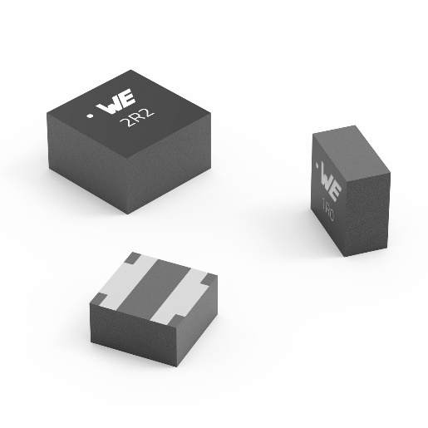Image source: Würth Elektronik
The WE-MXGI power inductor features extremely low R_{DC} and AC losses.

About the Würth Elektronik eiSos Group
Würth Elektronik eiSos Group is a manufacturer of electronic and electromechanical components for the electronics industry and a technology company that spearheads pioneering electronic solutions. Würth Elektronik eiSos is one of the largest European manufacturers of passive components and is active in 50 countries. Production sites in Europe, Asia and North America supply a growing number of customers worldwide.
The product range includes EMC components, inductors, transformers, RF components, varistors, capacitors, resistors, quartz crystals, oscillators, power modules, Wireless Power Transfer, LEDs, sensors, radio modules, connectors, power supply elements, switches, push-buttons, connection technology, fuse holders and solutions for wireless data transmission. The portfolio is complemented by customized solutions.
The unrivaled service orientation of the company is characterized by the availability of all catalog components from stock without minimum order quantity, free samples and extensive support through technical sales staff and selection tools.
Würth Elektronik is part of the Würth Group, the global market leader in the development, production, and sale of fastening and assembly materials, and employs 7,900 people. In 2023, the Würth Elektronik Group generated sales of 1.24 Billion Euro.

Würth Elektronik: more than you expect!
Further information at www.we-online.com

Further information:  Würth Elektronik eiSos GmbH & Co. KG  Sarah Hurst  Clarita-Bernhard-Strasse 9  81249 Munich  Germany  Phone: +49 7942 945-5186  E-mail: sarah.hurst@we-online.de  www.we-online.com | Press contact:  HighTech communications GmbH  Brigitte Basilio  Brunhamstrasse 21  81249 Munich  Germany  Phone: +49 89 500778-20  E-mail: b.basilio@htcm.de  www.htcm.de

