PRESS RELEASE

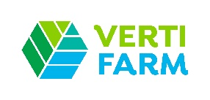
Würth Elektronik at the VertiFarm, October 8-10, 2024
Optimizing crops with horticulture LEDs
Waldenburg (Germany), October 2, 2024 – Würth Elektronik will be represented with its own stand at VertiFarm, the first and only dedicated trade fair for vertical farming and new food. The manufacturer of reliable electronic and electromechanical components and know-how transfer will demonstrate how it enables innovations in plant and algae production.
“In view of a growing world population, advancing climate change, and rising transportation costs, we need to make the production of crops more efficient, more environmentally friendly, and more consumer-friendly now and in the future,” explains Alexander Gerfer, CTO at Würth Elektronik eiSos. “Vertical farming is a sensible and necessary addition to traditional agriculture.”
8-10 October 2024
Hall 2, Booth 2.B02
Showing what is already possible today
Würth Elektronik has been promoting the development of indoor vertical farming and algae cultivation for some time now with its own research and startup collaborations. At booth 2.B02, Würth Elektronik will demonstrate how various projects are supported with plant-optimized lighting using special horticulture LEDs and modern sensor and communication technology. “At VertiFarm, we will show what is already feasible and being implemented today - with concepts that we have helped to develop and with components that we can also supply immediately from stock in large quantities,” assures Gerfer.
Cultivating plants to measure
“The precisely controllable environment in indoor cultivation has many advantages,” adds Johann Waldherr, Business Development Manager Electronic Power & Lighting Solutions at Würth Elektronik eiSos. “With the help of plant-optimized lighting, we can specifically influence, maximize and standardize the formation of certain ingredients. Optimized plant cultivation with multi-channel lights will also be the subject of Johann Waldherr's presentation on October 10 at 10:45 a.m. on the VertiFarm Stage in Hall 2 with the title “Sustainable Lighting Concepts for Indoor Cannabis Farming in Repurposed Agricultural Spaces”.

VertiFarm, October 8-10, 2024, Dortmund Exhibition Center
Tickets at https://www.vertifarm.de/ticketshop

Available images
The following images can be downloaded from the Internet in printable quality: https://kk.htcm.de/press-releases/wuerth/
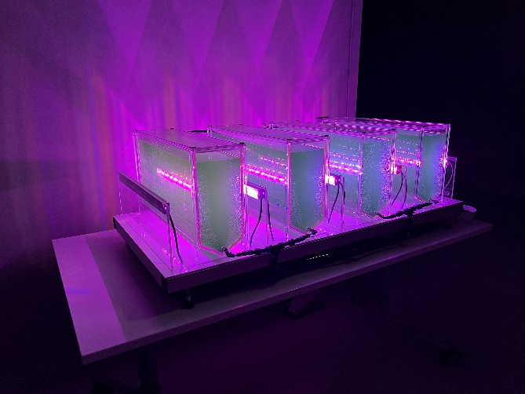
Image source: Würth Elektronik
Experimental setup with LED lighting system for microalgae production under controlled conditions.

About the Würth Elektronik eiSos Group
Würth Elektronik eiSos Group is a manufacturer of electronic and electromechanical components for the electronics industry and a technology company that spearheads pioneering electronic solutions. Würth Elektronik eiSos is one of the largest European manufacturers of passive components and is active in 50 countries. Production sites in Europe, Asia and North America supply a growing number of customers worldwide.
The product range includes EMC components, inductors, transformers, RF components, varistors, capacitors, resistors, quartz crystals, oscillators, power modules, Wireless Power Transfer, LEDs, sensors, radio modules, connectors, power supply elements, switches, push-buttons, connection technology, fuse holders and solutions for wireless data transmission. The portfolio is complemented by customized solutions.

The unrivaled service orientation of the company is characterized by the availability of all catalog components from stock without minimum order quantity, free samples and extensive support through technical sales staff and selection tools.
Würth Elektronik is part of the Würth Group, the global market leader in the development, production, and sale of fastening and assembly materials, and employs 7,900 people. In 2023, the Würth Elektronik Group generated sales of 1.24 Billion Euro.
Würth Elektronik: more than you expect!
Further information at www.we-online.com

Further information:  Würth Elektronik eiSos GmbH & Co. KG  Sarah Hurst  Clarita-Bernhard-Strasse 9  81249 Munich  Germany  Phone: +49 7942 945-5186  E-mail: sarah.hurst@we-online.de  www.we-online.com | Press contact:  HighTech communications GmbH  Brigitte Basilio  Brunhamstrasse 21  81249 Munich  Germany  Phone: +49 89 500778-20  E-mail: b.basilio@htcm.de  www.htcm.de

