PRESS RELEASE
Würth Elektronik at PEDC 2025
Importance of AI in Electronics
Waldenburg (Germany), January 14, 2025 – On January 29 to 30, 2025, the Pan-European Electronics Design Conference (PEDC) will convene leading experts from industry and research in Vienna. This newly launched event is dedicated to the entire development cycle of electronic systems. Würth Elektronik will contribute to the extensive program and host a panel on artificial intelligence.
“The experts agree that artificial intelligence will fundamentally change our lives,” explains Alexander Gerfer, CTO of the Würth Elektronik eiSos Group, a key supporter of the conference. “For Würth Elektronik, innovation, and therefore artificial intelligence, is by no means an end in itself, but a highly effective method of achieving our goal. Electronics for positive impact. Electronics should make our everyday lives easier, more pleasant, safer and more efficient. We need to use them to preserve our living space. And that is exactly what we want to discuss here at PEDC.”
The role of AI in electronics - panel with international experts

Alexander Gerfer, a member of the Technical Program Committee, will moderate the discussion “The Role of AI in Electronics” on January 29 at 2:15 PM. Following the discussion, an expert panel featuring renowned international participants will explore the topic further. These experts include the following:

- Prof. Dr. Thomas Ebel (University of Southern Denmark)
- Francis D’Souza (Banyan.eco, France)
- Savita Ganjigatti (Sienna ECAD Technologies, India)
- Dr. Reinhardt Seidel (DEEPTRONICS, Germany)

The PEDC is jointly organized by the FED and IPC associations, which together represent more than 3700 companies from the electronics industry. The conference aims to bridge the gap between industry and research in order to promote the exchange of information on the latest developments in electronics design.
The event will focus on forward-looking topics such as artificial intelligence, sustainability, advanced packaging, and digital twin technology. With a diverse program, PEDC offers participants a platform to discuss innovative approaches and actively shape the electronics industry.

Pan-European
Electronics Design Conference
29–30 January 2025
NH Danube City
Wagramer Straße 21
1220 Wien
Austria
https://pedc.eu/registration/

About PEDC
The 1st Pan-European Electronics Design Conference (PEDC) is a pan-European conference with in-depth technical and scientific presentations and high-caliber panels. It will take place on January 29 and 30 in Vienna. The conference focuses on connecting the European RE industry and scientific community and highlights the latest developments in electronics design, from silicon to system. Topics include Artificial Intelligence, Digital Twin, Advanced Packaging, High Frequency and Power Electronics, Development, Design for Excellence, Software and Tools or Product Life Cycle.

Available images
The following images can be downloaded from the Internet in printable quality: https://kk.htcm.de/press-releases/wuerth/
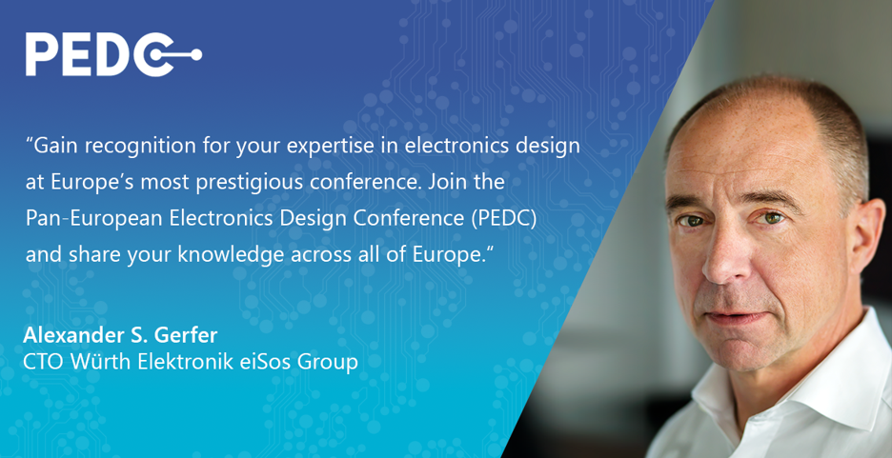
Image source: Würth Elektronik
Moderates the AI in Electronics panel: Alexander Gerfer, CTO, Würth Elektronik eiSos Group

About the Würth Elektronik eiSos Group
Würth Elektronik eiSos Group is a manufacturer of electronic and electromechanical components for the electronics industry and a technology company that spearheads pioneering electronic solutions. Würth Elektronik eiSos is one of the largest European manufacturers of passive components and is active in 50 countries. Production sites in Europe, Asia and North America supply a growing number of customers worldwide.
The product range includes EMC components, inductors, transformers, RF components, varistors, capacitors, resistors, quartz crystals, oscillators, power modules, Wireless Power Transfer, LEDs, sensors, radio modules, connectors, power supply elements, switches, push-buttons, connection technology, fuse holders and solutions for wireless data transmission. The portfolio is complemented by customized solutions.
The unrivaled service orientation of the company is characterized by the availability of all catalog components from stock without minimum order quantity, free samples and extensive support through technical sales staff and selection tools.
Würth Elektronik is part of the Würth Group, the global market leader in the development, production, and sale of fastening and assembly materials, and employs 7,900 people. In 2023, the Würth Elektronik Group generated sales of 1.24 Billion Euro.
Würth Elektronik: more than you expect!
Further information at www.we-online.com

Further information:  Würth Elektronik eiSos GmbH & Co. KG  Sarah Hurst  Clarita-Bernhard-Strasse 9  81249 Munich  Germany  Phone: +49 7942 945-5186  E-mail: sarah.hurst@we-online.de  www.we-online.com | Press contact:  HighTech communications GmbH  Brigitte Basilio  Brunhamstrasse 21  81249 Munich  Germany  Phone: +49 89 500778-20  E-mail: b.basilio@htcm.de  www.htcm.de

