PRESS RELEASE

Würth Elektronik expands its FPC connector family
Gold Plating: Better for Flexible Printed Circuits
Waldenburg (Germany), October 30, 2024 – The selection of connectors for flat flexible cables (FFC) and flexible printed circuits (FPC) from Würth Elektronik is getting even larger. The manufacturer of electronic and electromechanical components now offers WR-FPC ZIF connectors (Zero Insertion Force) with locking mechanism, and featuring gold-plated contacts. Gold over nickel on the connector strip improves electrical conductivity, wear resistance, corrosion resistance, and reliability. The new variant is primarily aimed at connecting flexible printed circuits.
The mechanical properties and polarity of the gold-plated connectors are identical to the standard series with tin plating, so no design changes are required if a customer wishes to upgrade. In addition to improved conductivity and signal quality, the FPC connectors offer another advantage: FPCs usually have gold-plated contacts. The new connectors avoid mixing gold and tin in the transition zone. Gold and tin form an electrochemical series, which can cause corrosion and limit the service life of the connection. It is therefore recommended to ensure that gold is combined with gold and tin with tin on the contact surfaces.
The FPC connectors with gold-plated contacts are now available.

Available images
The following images can be downloaded from the Internet in printable quality: https://kk.htcm.de/press-releases/wuerth/

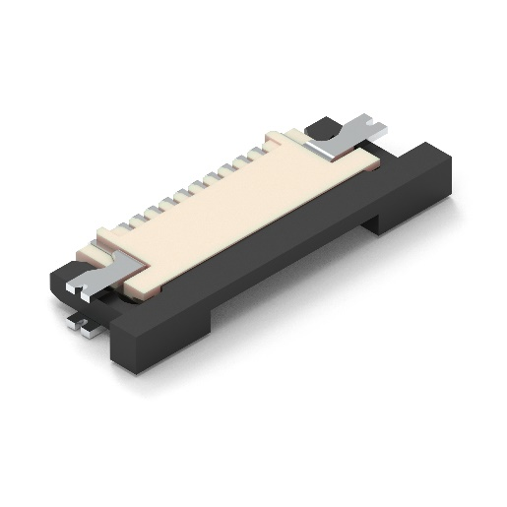Image source: Würth Elektronik
WR-FPC connector with gold-plated contacts

About the Würth Elektronik eiSos Group
Würth Elektronik eiSos Group is a manufacturer of electronic and electromechanical components for the electronics industry and a technology company that spearheads pioneering electronic solutions. Würth Elektronik eiSos is one of the largest European manufacturers of passive components and is active in 50 countries. Production sites in Europe, Asia and North America supply a growing number of customers worldwide.
The product range includes EMC components, inductors, transformers, RF components, varistors, capacitors, resistors, quartz crystals, oscillators, power modules, Wireless Power Transfer, LEDs, sensors, radio modules, connectors, power supply elements, switches, push-buttons, connection technology, fuse holders and solutions for wireless data transmission. The portfolio is complemented by customized solutions.
The unrivaled service orientation of the company is characterized by the availability of all catalog components from stock without minimum order quantity, free samples and extensive support through technical sales staff and selection tools.
Würth Elektronik is part of the Würth Group, the global market leader in the development, production, and sale of fastening and assembly materials, and employs 7,900 people. In 2023, the Würth Elektronik Group generated sales of 1.24 Billion Euro.
Würth Elektronik: more than you expect!
Further information at www.we-online.com

Further information:  Würth Elektronik eiSos GmbH & Co. KG  Sarah Hurst  Clarita-Bernhard-Strasse 9  81249 Munich  Germany  Phone: +49 7942 945-5186  E-mail: sarah.hurst@we-online.de  www.we-online.com | Press contact:  HighTech communications GmbH  Brigitte Basilio  Brunhamstrasse 21  81249 Munich  Germany  Phone: +49 89 500778-20  E-mail: b.basilio@htcm.de  www.htcm.de

