PRESS RELEASE

Children’s vacation activity programme at Würth Elektronik
Summer-vacation care provides relief for working parents
Waldenburg (Germany), August 13, 2024 – Summer, sunshine, happy children: the start of the summer school holidays at Würth Elektronik was marked by a children’s vacation programme full of different activities. From 29 July until 2 August a total of 31 children of ages 6 to 12 took part in the programme at the headquarters of the manufacturer of electronic and electromechanical components in Waldenburg.
Handicrafts, romping around, elementary science experiments, or soccer – there was a lot on offer in the meeting rooms, the company’s own sports facilities, and on the spacious meadow in front of the office building to give the kids an interesting and varied week in their summer vacation. In addition, two special event days titled “Renewable Energies” and “Digital World” provided plenty of material for learning by playing. A special highlight was the daytrip to Germany’s largest science centre, the “experimenta” in Heilbronn. Meals were prepared afresh each day by the Panorama Catering team. One particularly nice side-effect on top of fun and games with other children: the kids got the chance to find out more about their parents’ workplaces in a playful way.
“Many working parents are familiar with the situation: the long summer holiday can be a great challenge from the organisational viewpoint,“ says Christina Braun, who was involved in the coordination of the programme in her capacity as member of the “Lebenslagen” (Life Stages) project team at Würth Elektronik. “There’s a discrepancy between the number of vacation days for the parents and the length of the summer holidays. This makes it important for us to support our employees by offering an opportunity to narrow any gap in the care of their kids during the holiday period,“ adds Melanie Sinzinger, also a member of the organisation team. The summer-vacation care programme was put on in cooperation with the Proki Kinderevents GmbH agency in Bonn, which has sites throughout Germany. At the end everyone agreed: the event was a complete success – and we all look forward to repeating it again in the next summer holidays.

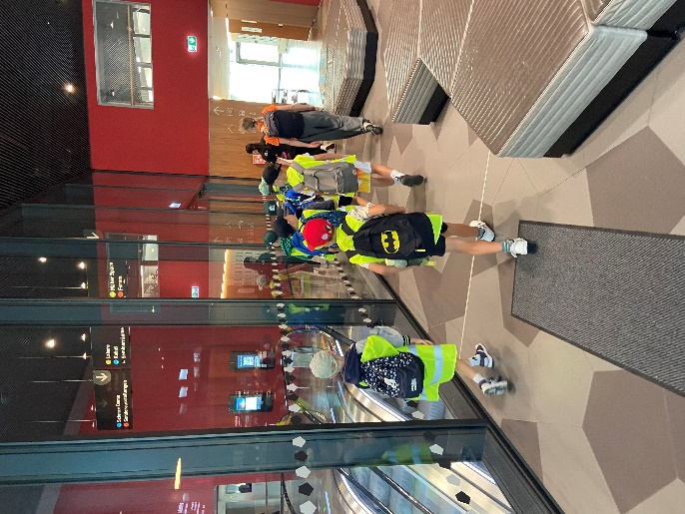  Image source: Würth Elektronik  Children taking part in Würth Elektronik’s vacation programme visited the “experimenta” science centre in Heilbronn. | 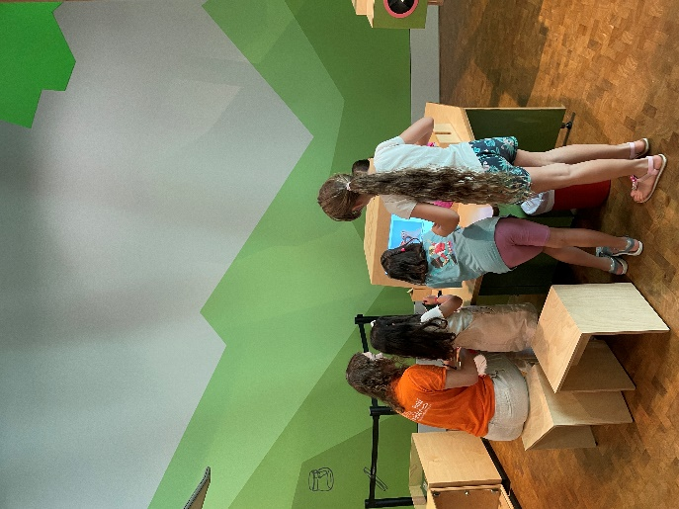  Image source: Würth Elektronik  The “experimenta” provides plenty of interactive stations for little discoverers and researchers.
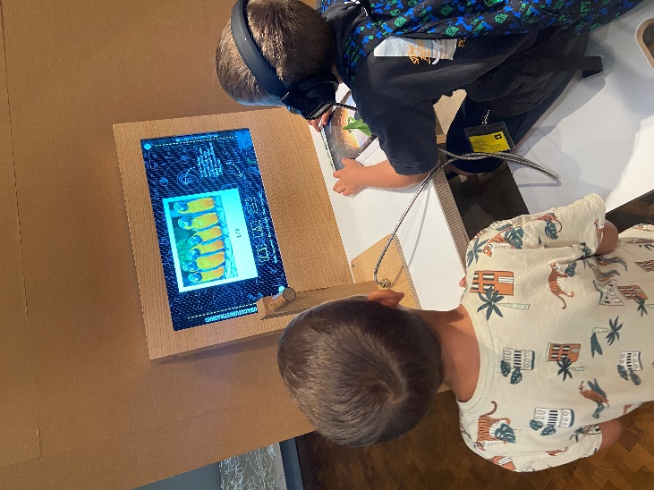
Image source: Würth Elektronik
Multimedial knowledge transfer at Würth Elektronik’s vacation programme.

About the Würth Elektronik eiSos Group
Würth Elektronik eiSos Group is a manufacturer of electronic and electromechanical components for the electronics industry and a technology company that spearheads pioneering electronic solutions. Würth Elektronik eiSos is one of the largest European manufacturers of passive components and is active in 50 countries. Production sites in Europe, Asia and North America supply a growing number of customers worldwide.
The product range includes EMC components, inductors, transformers, RF components, varistors, capacitors, resistors, quartz crystals, oscillators, power modules, Wireless Power Transfer, LEDs, sensors, radio modules, connectors, power supply elements, switches, push-buttons, connection technology, fuse holders and solutions for wireless data transmission. The portfolio is complemented by customized solutions.
The unrivaled service orientation of the company is characterized by the availability of all catalog components from stock without minimum order quantity, free samples and extensive support through technical sales staff and selection tools.
Würth Elektronik is part of the Würth Group, the global market leader in the development, production, and sale of fastening and assembly materials, and employs 7,900 people. In 2023, the Würth Elektronik Group generated sales of 1.24 Billion Euro.
Würth Elektronik: more than you expect!
Further information at www.we-online.com

Further information:  Würth Elektronik eiSos GmbH & Co. KG  Sarah Hurst  Clarita-Bernhard-Strasse 9  81249 Munich  Germany  Phone: +49 7942 945-5186  E-mail: sarah.hurst@we-online.de  www.we-online.com | Press contact:  HighTech communications GmbH  Brigitte Basilio  Brunhamstrasse 21  81249 Munich  Germany  Phone: +49 89 500778-20  E-mail: b.basilio@htcm.de  www.htcm.de

