PRESS RELEASE

Würth Elektronik introduces its Ophelia-III radio module
Perfect for Proprietary Solutions
Waldenburg (Germany), October 1, 2024 – The compact Ophelia-III radio module is offered as part of Würth Elektronik’s “Build Your Own Firmware” concept. The manufacturer enables custom radio solutions in the 2402 to 2480 MHz frequency range to be developed with this module, which comes without firmware and a software development kit (SDK). Applications range from the widely used Bluetooth® LE for specific use to proprietary, highly customized radio protocols.
Ophelia-III is based on the nRF52840 chipset from Nordic Semiconductor, a 32-bit ARM Cortex M4F CPU, and is equipped with 1 MB of flash memory, 256 kB RAM, and various interfaces (UART, SPI, I²C, ADC, 17 GPIOs, Nano-SIM). The module, measuring 12 × 8 × 2 mm, is more compact than comparable models on the market. Thanks to its optimized antenna design, it features low power consumption at a transmission power up to +8 dBm. In sleep mode, the current drawn is just 0.4 µA – making the module ideal for battery-powered devices. Würth Elektronik places particular importance on providing freedom in application development with this radio module. Ophelia-III has both an antenna connector and an internal antenna, as well as 17 configurable GPIOs.
The radio module is based on the same hardware platform as the proven Proteus-III Bluetooth® LE module, whose certification documents can be reused to certify Ophelia-III solutions. An evaluation board and an SDK are available for application development.

Available images
The following images can be downloaded from the Internet in printable quality: https://kk.htcm.de/press-releases/wuerth/

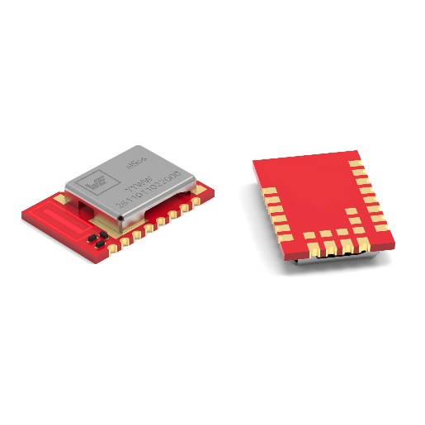
Image source: Würth Elektronik
Ophelia-III, a compact and energy-efficient “Build Your Own Firmware” radio module for the 2402 to 2480 MHz frequency range.

About the Würth Elektronik eiSos Group
Würth Elektronik eiSos Group is a manufacturer of electronic and electromechanical components for the electronics industry and a technology company that spearheads pioneering electronic solutions. Würth Elektronik eiSos is one of the largest European manufacturers of passive components and is active in 50 countries. Production sites in Europe, Asia and North America supply a growing number of customers worldwide.
The product range includes EMC components, inductors, transformers, RF components, varistors, capacitors, resistors, quartz crystals, oscillators, power modules, Wireless Power Transfer, LEDs, sensors, radio modules, connectors, power supply elements, switches, push-buttons, connection technology, fuse holders and solutions for wireless data transmission. The portfolio is complemented by customized solutions.
The unrivaled service orientation of the company is characterized by the availability of all catalog components from stock without minimum order quantity, free samples and extensive support through technical sales staff and selection tools.
Würth Elektronik is part of the Würth Group, the global market leader in the development, production, and sale of fastening and assembly materials, and employs 7,900 people. In 2023, the Würth Elektronik Group generated sales of 1.24 Billion Euro.
Würth Elektronik: more than you expect!
Further information at www.we-online.com

Further information:  Würth Elektronik eiSos GmbH & Co. KG  Sarah Hurst  Clarita-Bernhard-Strasse 9  81249 Munich  Germany  Phone: +49 7942 945-5186  E-mail: sarah.hurst@we-online.de  www.we-online.com | Press contact:  HighTech communications GmbH  Brigitte Basilio  Brunhamstrasse 21  81249 Munich  Germany  Phone: +49 89 500778-20  E-mail: b.basilio@htcm.de  www.htcm.de

