PRESS RELEASE

New 2.4-GHz radio modules from Würth Elektronik
Compact, Energy-saving, Universal
Waldenburg (Germany), January 16, 2025 – Würth Elektronik, manufacturer of electronic and electromechanical components for the electronics industry, presents its new wireless modules: the freely configurable Orthosie-I model and the Stephano-I variant with pre-installed firmware. Both are based on the ESP32-C3 chipset and communicate according to the IEEE 802.11 b/g/n and Bluetooth® LE 5.0 standards. The new components feature an integrated antenna and, thanks to their space-saving design, are very flexible to use.
Wireless communication is now used in many areas of our daily lives – in blood glucose meters that transmit results to a smartphone, thermostats or lawn-mowing robots with a visual interface app, or in cordless power tools that automatically activate a Bluetooth®-linked dust vacuum when they start up. Würth Elektronik now offers the suitable radio modules for these and many other applications.
Optimized to save energy and space
The modules feature an integrated antenna. They have been specially optimized for energy-saving operation without compromising wireless range. Updating via wireless connection is also possible (FOTA, Firmware Over The Air). The developers at Würth Elektronik have also managed to reduce the TX current consumption and form factor by 50 percent compared to the ESP32-C3-MINI-1 module. In power-off mode, the modules, which measure just 13 × 9.5 × 2 mm, consume only 1 µA.
The innovative communication components are based on a 32-bit RISC-V single-core processor from Espressif (ESP32-C3), which can operate at a clock frequency of up to 160 MHz. They have 4 MB of flash memory and 400 kB of RAM. In addition, 15 freely configurable GPIO pins (General Purpose Input/Output) are available.
Available with or without pre-installed firmware
The Orthosie-I module is supplied without pre-installed firmware and can be individually programmed for the specific application. Various interfaces can also be implemented, such as UART, SPI, I²C, and ADC.
Stephano-I comes with high-quality, pre-installed firmware, a complete TCP/IP-Stack, MQTT and HTTP. The versatile module can act both as a station and as a soft access point. In soft-access-point mode, the encryption modes WPAPSK, WPA2PSK, and WPA/WPA2PSK are available. Up to three Bluetooth® LE connections can be established simultaneously. The practical and time saving “WE Bluetooth® LE Terminal” app from Würth Elektronik offers a quick and easy testing option as well as the basis for your own apps (available free of charge from Google Play Store® and Apple App Store®, or as source code on GitHub).

Available images
The following images can be downloaded from the Internet in printable quality: https://kk.htcm.de/press-releases/wuerth/
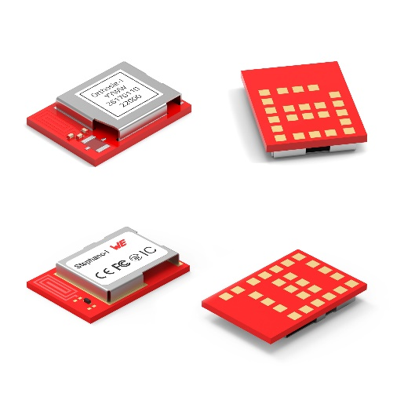
Image source: Würth Elektronik
New Orthosie-I (above) and Stephano-I (below) radio modules from Würth Elektronik: Universally applicable – from glucose meters to lawn-mowing robots.

About the Würth Elektronik eiSos Group
Würth Elektronik eiSos Group is a manufacturer of electronic and electromechanical components for the electronics industry and a technology company that spearheads pioneering electronic solutions. Würth Elektronik eiSos is one of the largest European manufacturers of passive components and is active in 50 countries. Production sites in Europe, Asia and North America supply a growing number of customers worldwide.
The product range includes EMC components, inductors, transformers, RF components, varistors, capacitors, resistors, quartz crystals, oscillators, power modules, Wireless Power Transfer, LEDs, sensors, radio modules, connectors, power supply elements, switches, push-buttons, connection technology, fuse holders and solutions for wireless data transmission. The portfolio is complemented by customized solutions.

The unrivaled service orientation of the company is characterized by the availability of all catalog components from stock without minimum order quantity, free samples and extensive support through technical sales staff and selection tools.
Würth Elektronik is part of the Würth Group, the global market leader in the development, production, and sale of fastening and assembly materials, and employs 7,900 people. In 2023, the Würth Elektronik Group generated sales of 1.24 Billion Euro.
Würth Elektronik: more than you expect!
Further information at www.we-online.com

Further information:  Würth Elektronik eiSos GmbH & Co. KG  Sarah Hurst  Clarita-Bernhard-Strasse 9  81249 Munich  Germany  Phone: +49 7942 945-5186  E-mail: sarah.hurst@we-online.de  www.we-online.com | Press contact:  HighTech communications GmbH  Brigitte Basilio  Brunhamstrasse 21  81249 Munich  Germany  Phone: +49 89 500778-20  E-mail: b.basilio@htcm.de  www.htcm.de

