PRESS RELEASE
Würth Elektronik opens prototype laboratory
Customized Transformers
Munich (Germany), December 5, 2024 – Wurth Electronics Midcom Inc., German Branch, with EU headquarters in Munich, has opened a laboratory for the production of transformer prototypes at the Hightech Innovation Center in Munich-Freiham. The company, which specializes in transformers for switch-mode power supplies and customized inductive components, is part of the Würth Elektronik eiSos Group. In Munich, they produce custom magnetics prototypes using first-class equipment and high-quality materials. On November 11, 2024, the new facility was presented to customers and partners including a tour of the test fields, EMC chambers and the office and meeting areas designed according to modern New Work aspects.
The main purpose of the new capacities is to promote intensive and transparent collaboration with customers. In-house prototype development and production enables the design engineers to also accompany their process in its implementation. All products are tested individually using advanced equipment and methods. The facility's technical equipment offers new opportunities for R&D projects and patent development. Students and young talents also benefit from the site's extensive equipment for research and final theses. In the future, prototypes of high-performance products and wireless power coils will also be produced here at the Hightech Innovation Center in Munich.

Available images
The following images can be downloaded from the Internet in printable quality: https://kk.htcm.de/press-releases/wuerth/

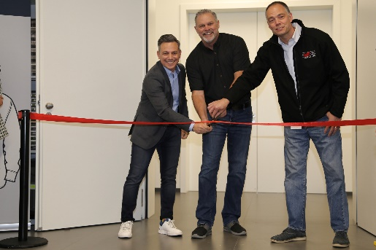Image source: Würth Elektronik
Cem Som, Vice President at Wurth Electronics Midcom Europe, Don Rigdon, President at Wurth Electronics Midcom and Dominik Kern, President at Wurth Electronics Midcom (from left to right), opening the prototype lab at the Hightech Innovation Center in Munich-Freiham.

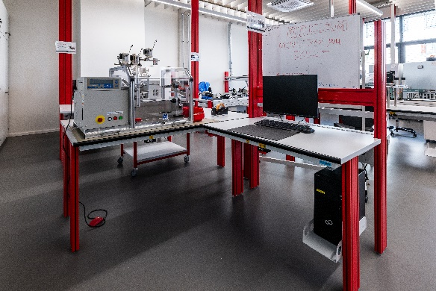  Image source: Würth Elektronik  Modern laboratory equipment: First-class equipment for the implementation of in-house concepts | 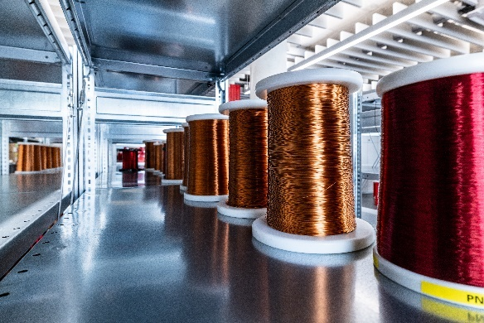  Image source: Würth Elektronik  Material warehouse: Winding wire for prototypes of customer-specific transformers

About the Würth Elektronik eiSos Group
Würth Elektronik eiSos Group is a manufacturer of electronic and electromechanical components for the electronics industry and a technology company that spearheads pioneering electronic solutions. Würth Elektronik eiSos is one of the largest European manufacturers of passive components and is active in 50 countries. Production sites in Europe, Asia and North America supply a growing number of customers worldwide.

The product range includes EMC components, inductors, transformers, RF components, varistors, capacitors, resistors, quartz crystals, oscillators, power modules, Wireless Power Transfer, LEDs, sensors, radio modules, connectors, power supply elements, switches, push-buttons, connection technology, fuse holders and solutions for wireless data transmission. The portfolio is complemented by customized solutions.
The unrivaled service orientation of the company is characterized by the availability of all catalog components from stock without minimum order quantity, free samples and extensive support through technical sales staff and selection tools.
Würth Elektronik is part of the Würth Group, the global market leader in the development, production, and sale of fastening and assembly materials, and employs 7,900 people. In 2023, the Würth Elektronik Group generated sales of 1.24 Billion Euro.
Würth Elektronik: more than you expect!
Further information at www.we-online.com

Further information:  Würth Elektronik eiSos GmbH & Co. KG  Sarah Hurst  Clarita-Bernhard-Strasse 9  81249 Munich  Germany  Phone: +49 7942 945-5186  E-mail: sarah.hurst@we-online.de  www.we-online.com | Press contact:  HighTech communications GmbH  Brigitte Basilio  Brunhamstrasse 21  81249 Munich  Germany  Phone: +49 89 500778-20  E-mail: b.basilio@htcm.de  www.htcm.de

