PRESS RELEASE
IQD introduces the OCXO IQOV-116 series at electronica 2024
Miniature form-factor and High Stability
Waldenburg (Germany), November 12, 2024 – IQD, part of the Würth Elektronik eiSos Group, is excited to announce the release of a new miniature OCXO in their range of enhanced performance oscillators: IQOV-116, at electronica (Munich, November 12–15, Hall A6, Würth Elektronik Booth 502). This extended operating temperature range of OCXOs offers high stability in an extremely small 7.5 x 5.5 mm surface mount package. It is the smallest SMD OCXO in the IQD range and brings OCXO performance down to the size of standard 7x5mm clock oscillators.
The IQOV-116 series has a HCMOS output and boasts a range of features including high stability of ±20 ppb over a wide temperature range of -40 to 95 °C, low phase noise (-150 dBc/Hz typ @ 1 KHz), 3.3 V supply voltage and low power consumption at 230 mA steady state. It comes in three standard frequencies: 10.0 MHz, 19.2 MHz and 20.0 MHz, with other frequencies available upon request.
This small device is ideal for a range of applications, including wireless communication, small cells and further communication infrastructure, frequency reference and measurement systems.
The IQOV-116 series can be supplied packaged on tape & reel which is ideal for assembly using standard ‘pick-n-place’ equipment.
An OCXO offers frequency stabilities much tighter than those seen in standard clock oscillators and even from TCXOs. The frequency drift of the quartz crystal, due to temperature shift, is reduced to a minimum by heating the crystal in an oven and holding the temperature of the quartz at a fixed point.

Available images
The following images can be downloaded from the Internet in printable quality: https://kk.htcm.de/press-releases/wuerth/

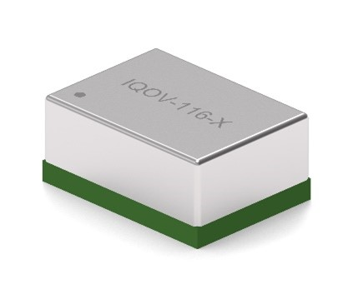

Image source: IQD Frequency Products Ltd
IQOV-116, a high-performance OCXO measuring just 7.5 x 5.5 mm

About IQD
Backed by over 50 years’ experience in the manufacture of frequency products, IQD is a recognised market leader in the frequency control market and part of the Würth Elektronik eiSos Group, one of the leading European manufacturers of passive components. With active customers in over 80 countries, IQD offers one of the most comprehensive frequency product ranges available, from low cost commercial grade product to that used in high reliability industrial and automotive applications including: Quartz Crystals, Clock Oscillators, AEC-Q200 Crystals & Oscillators, VCXOs, TCXOs, OCVCSOs & OCXOs, GPS Disciplined OCXOs, and Rubidium Oscillators.
Further info at www.iqdfrequencyproducts.com

About the Würth Elektronik eiSos Group
Würth Elektronik eiSos Group is a manufacturer of electronic and electromechanical components for the electronics industry and a technology company that spearheads pioneering electronic solutions. Würth Elektronik eiSos is one of the largest European manufacturers of passive components and is active in 50 countries. Production sites in Europe, Asia and North America supply a growing number of customers worldwide.
The product range includes EMC components, inductors, transformers, RF components, varistors, capacitors, resistors, quartz crystals, oscillators, power modules, Wireless Power Transfer, LEDs, sensors, radio modules, connectors, power supply elements, switches, push-buttons, connection technology, fuse holders and solutions for wireless data transmission. The portfolio is complemented by customized solutions.
The unrivaled service orientation of the company is characterized by the availability of all catalog components from stock without minimum order quantity, free samples and extensive support through technical sales staff and selection tools.
Würth Elektronik is part of the Würth Group, the global market leader in the development, production, and sale of fastening and assembly materials, and employs 7,900 people. In 2023, the Würth Elektronik Group generated sales of 1.24 Billion Euro.
Würth Elektronik: more than you expect!
Further information at www.we-online.com

Further information:  IQD Frequency Products Ltd  Liz Thompson  Station Road  Crewkerne  Somerset  TA18 8AR  United Kingdom  Phone: +44 1460 270270  E-mail: Liz.Thompson@iqdfrequencyproducts.com  www.we-online.com  www.iqdfrequencyproducts.com | Press contact:  HighTech communications GmbH  Brigitte Basilio  Brunhamstrasse 21  81249 Munich  Germany  Phone: +49 89 500778-20  E-mail:  b.basilio@htcm.de  www.htcm.de

