PRESS RELEASE
Würth Elektronik reference book on connectors, 4th edition
Connected
Waldenburg (Germany), December 10, 2024 – Würth Elektronik’s popular reference book Trilogy of Connectors has been published in its 4th edition. The well-known manufacturer of electronic and electromechanical components for the electronics industry has updated and completely revised its standard reference work. The application manual takes an in-depth look at the basics and latest trends in connectors.
Connectors are indispensable components in the electronics industry. If they don’t function flawlessly both mechanically and electrically, they’re a potential source of faults. Despite international efforts toward standards, like those with the USB connector, there are still many different variants and norms, complicating the choice of the right product.
The selection and dimensioning process becomes far easier with the standard reference work Trilogy of Connectors, now published in its 4th edition. The application handbook covers all the latest developments and trends. It also provides a wealth of practical information on various connector types, such as USB Type-C or USB Power Delivery. A newly added section addresses connectors for shielded cables and their EMC-compliant design.
The clear structure in three chapters remains:
- Chapter 1 covers the basic principles of connectors: function, base materials, and contact design. Developers can also find out here about the various assembly options with PCBs or cables.
- Chapter 2 deals with the technical parameters of connectors and their characterization.
- Chapter 3 contains practical application examples and provides a wealth of ideas for various applications.
Trilogy of Connectors is written in English and will also be available as an e-book in early 2025. The book can now be ordered directly from Würth Elektronik: https://shorturl.at/nr9PF

Available images
The following images can be downloaded from the Internet in printable quality: https://kk.htcm.de/press-releases/wuerth/
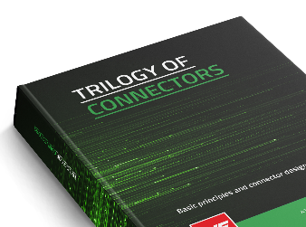
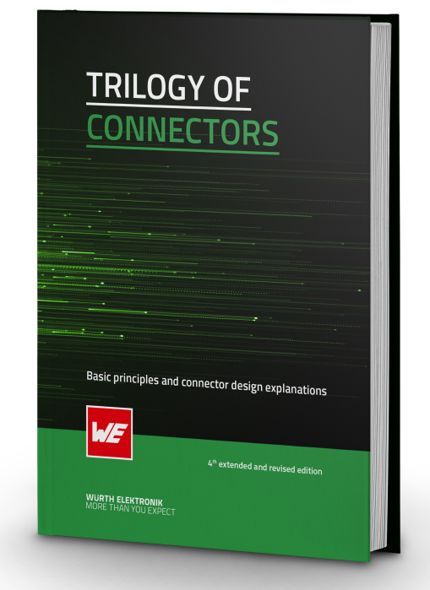
Image source: Würth Elektronik
Trilogy of Connectors: Basic Principles, Specifications, Applications

About the Würth Elektronik eiSos Group
Würth Elektronik eiSos Group is a manufacturer of electronic and electromechanical components for the electronics industry and a technology company that spearheads pioneering electronic solutions. Würth Elektronik eiSos is one of the largest European manufacturers of passive components and is active in 50 countries. Production sites in Europe, Asia and North America supply a growing number of customers worldwide.
The product range includes EMC components, inductors, transformers, RF components, varistors, capacitors, resistors, quartz crystals, oscillators, power modules, Wireless Power Transfer, LEDs, sensors, radio modules, connectors, power supply elements, switches, push-buttons, connection technology, fuse holders and solutions for wireless data transmission. The portfolio is complemented by customized solutions.
The unrivaled service orientation of the company is characterized by the availability of all catalog components from stock without minimum order quantity, free samples and extensive support through technical sales staff and selection tools.
Würth Elektronik is part of the Würth Group, the global market leader in the development, production, and sale of fastening and assembly materials, and employs 7,900 people. In 2023, the Würth Elektronik Group generated sales of 1.24 Billion Euro.

Würth Elektronik: more than you expect!
Further information at www.we-online.com

Further information:  Würth Elektronik eiSos GmbH & Co. KG  Sarah Hurst  Clarita-Bernhard-Strasse 9  81249 Munich  Germany  Phone: +49 7942 945-5186  E-mail: sarah.hurst@we-online.de  www.we-online.com | Press contact:  HighTech communications GmbH  Brigitte Basilio  Brunhamstrasse 21  81249 Munich  Germany  Phone: +49 89 500778-20  E-mail: b.basilio@htcm.de  www.htcm.de

