PRESS RELEASE

Würth Elektronik expands its MagI³C power module series with variable step-down module in LGA-12EP
Extremely Wide Input-voltage Range
Waldenburg (Germany), January 22, 2025 – With MagI³C-VDLM, Würth Elektronik presents three power modules in the LGA-12EP package for the 24 V industrial power bus. The modules are characterized by high resilience to voltage transients on the 24 V bus and an extremely wide input-voltage range from 3.5 V to 38 V. The module, measuring just 10 × 6 × 3.1 mm, is available with an output current of 1, 2, or 3 A.
The MagI³C-VDLM series of power modules offers a fully integrated DC/DC power supply that combines all essential components in a compact package: switching regulator with integrated MOSFETs, controller, compensation circuitry, and a shielded inductor. The power module maintains a constant, selectable PWM switching frequency across the operating range, thereby optimizing output ripple for sensitive and precise applications. It achieves peak efficiency up to 94 percent.
The MagI³C-VDLM power modules are designed for use in point-of-load DC/DC applications on 24 V, 12 V, and 5 V buses. Typical applications include test and measurement technology, medical technology, industrial electronics, and telecommunications. The module is ideally suited for supplying interfaces, microcontrollers, microprocessors, digital signal processors, and field-programmable gate arrays. It has excellent EMC behavior and complies with the EN55032 Class B / CISPR-32 standard.

Available images
The following images can be downloaded from the Internet in printable quality: https://kk.htcm.de/press-releases/wuerth/

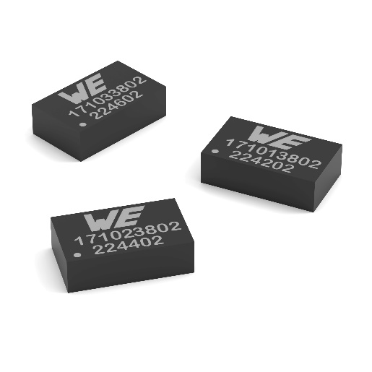
Image source: Würth Elektronik
The expanded MagI³C-VDLM power module series is suitable for direct connection to the 24 V industrial power supply network.

About the Würth Elektronik eiSos Group
Würth Elektronik eiSos Group is a manufacturer of electronic and electromechanical components for the electronics industry and a technology company that spearheads pioneering electronic solutions. Würth Elektronik eiSos is one of the largest European manufacturers of passive components and is active in 50 countries. Production sites in Europe, Asia and North America supply a growing number of customers worldwide.
The product range includes EMC components, inductors, transformers, RF components, varistors, capacitors, resistors, quartz crystals, oscillators, power modules, Wireless Power Transfer, LEDs, sensors, radio modules, connectors, power supply elements, switches, push-buttons, connection technology, fuse holders and solutions for wireless data transmission. The portfolio is complemented by customized solutions.
The unrivaled service orientation of the company is characterized by the availability of all catalog components from stock without minimum order quantity, free samples and extensive support through technical sales staff and selection tools.
Würth Elektronik is part of the Würth Group, the global market leader in the development, production, and sale of fastening and assembly materials, and employs 7,900 people. In 2023, the Würth Elektronik Group generated sales of 1.24 Billion Euro.

Würth Elektronik: more than you expect!
Further information at www.we-online.com

Further information:  Würth Elektronik eiSos GmbH & Co. KG  Sarah Hurst  Clarita-Bernhard-Strasse 9  81249 Munich  Germany  Phone: +49 7942 945-5186  E-mail: sarah.hurst@we-online.de  www.we-online.com | Press contact:  HighTech communications GmbH  Brigitte Basilio  Brunhamstrasse 21  81249 Munich  Germany  Phone: +49 89 500778-20  E-mail: b.basilio@htcm.de  www.htcm.de

