PRESS RELEASE

Würth Elektronik presents its ICLED Color Calculator
Determining and Setting Precise Color Values for RGB LEDs
Waldenburg (Germany), March 20, 2025 – Würth Elektronik presents ICLED Color Calculator – a new service on its REDEXPERT online platform. This unique, free tool allows developers to quickly and accurately determine the exact PWM values needed to achieve specific ICLED color values, without requiring additional measurements. Würth Elektronik determines these parameters for each batch before it leaves the warehouse. The advantage: accurate color rendering without additional effort. This expands the options for ICLED lighting and signaling solutions and accelerates their development.
The REDEXPERT ICLED Color Calculator features an intuitive user interface, allowing users to select the desired ICLED type, batch, as well as color and brightness in the CIE 1931 standard color system (“xy color space”). The tool then automatically generates the appropriate digital signals for pulse width modulation (PWM) of the RGB LEDs within the ICLED component. These values can be directly adopted in the programming. This is possible thanks to the meticulous sorting process during ICLED production. Würth Elektronik only offers LEDs with consistent color temperature and brightness properties for each batch. The precision of quality control and binning enables the company to open up new options for advanced LED applications using its innovative development tool.
Design options in light
“The ICLED Color Calculator is the first tool of its kind and further strengthens our position as a service leader. No other manufacturer offers a comparable solution that supports customers all the way through to the production phase,” stresses Alexander Gerfer, CTO at Würth Elektronik eiSos. Carlos Roberto Hernandez Gomez, Product Manager for ICLEDs at Würth Elektronik eiSos, adds: “This tool significantly reduces workload by eliminating the need for manually testing the color combinations. Developers can now select from over 16 million color options and immediately generate the appropriate signal.”

Available images
The following images can be downloaded from the Internet in printable quality: https://kk.htcm.de/press-releases/wuerth/
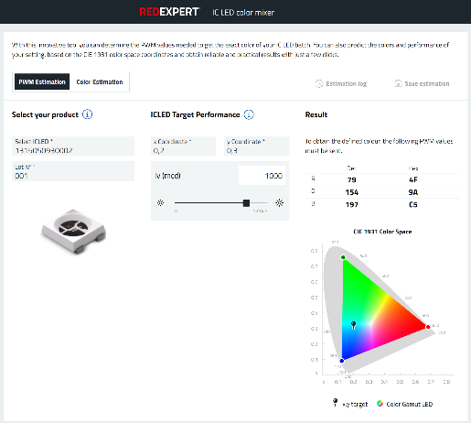
Image source: Würth Elektronik
Select the component, bin, and color, and the REDEXPERT ICLED Color Calculator outputs the values for PWM control.

About the Würth Elektronik eiSos Group
Würth Elektronik eiSos Group is a manufacturer of electronic and electromechanical components for the electronics industry and a technology company that spearheads pioneering electronic solutions. Würth Elektronik eiSos is one of the largest European manufacturers of passive components and is active in 50 countries. Production sites in Europe, Asia and North America supply a growing number of customers worldwide.
The product range includes passive components, power modules, digital isolators, optoelectronics, electromechanical components, thermal management solutions, sensors and wireless modules. The portfolio is rounded off by customer-specific solutions.
The unrivaled service orientation of the company is characterized by the availability of all catalog components from stock without minimum order quantity, free samples and extensive support through technical sales staff and selection tools.

Würth Elektronik is part of the Würth Group, the global market leader in the development, production, and sale of fastening and assembly materials, and employs around 7,500 people. The Würth Elektronik Group generated sales of 1 Billion Euro (all figures according to preliminary results for 2024).
Würth Elektronik: more than you expect!
Further information at www.we-online.com

Further information:  Würth Elektronik eiSos GmbH & Co. KG  Sarah Hurst  Clarita-Bernhard-Strasse 9  81249 Munich  Germany  Phone: +49 7942 945-5186  E-mail: sarah.hurst@we-online.de  www.we-online.com | Press contact:  HighTech communications GmbH  Brigitte Basilio  Brunhamstrasse 21  81249 Munich  Germany  Phone: +49 89 500778-20  E-mail: b.basilio@htcm.de  www.htcm.de

