PRESS RELEASE
Together for a Merry Christmas
Employees of Würth Elektronik give Hope and Joy
Waldenburg, Schwäbisch-Hall (Germany), December 18, 2024 – Making a big difference with small gestures: Once again this year, Würth Elektronik is sending out a strong signal of solidarity and regional responsibility. The company is supporting the Schwäbisch Hall Deaconry Association's Christmas tree campaign to give children and families in need of support in the region a festive Christmas. Thanks to the generous participation of its employees, Würth Elektronik is fulfilling 40 specific Christmas wishes, and providing financial support for other projects of the Diakonieverband.
With great commitment, Würth Elektronik is once again participating in the popular wish tree campaign of the Diakonieverband in Schwäbisch Hall. With the generous donations of the employees totaling 3,363 Euro, 40 gift wishes from the Christmas tree in St. Michael's Church in Schwäbisch Hall were fulfilled and the important work of the Diakonieverband was supported financially.
A strong signal in challenging times
The current social situation shows the urgent need for solidarity. According to the latest poverty report by the Paritätischer Gesamtverband, around 14.2 million people in Germany are affected by poverty, including one in five children. “These figures highlight our responsibility to make a contribution. Christmas should be a celebration of hope and joy for everyone,” emphasizes Caroline Greitzke, Head of Training at Würth Elektronik eiSos.
Young talents at work
The “Young Talents”, the team of apprentices and students from Würth Elektronik, play a central role in this project. They planned the entire campaign, collected donations and took care of purchasing the gifts and wrapping them lovingly. At the same time, they learn how social responsibility is practiced in the company. “This is a valuable opportunity for our young talents to get actively involved and internalize the core values of our corporate culture,” says Caroline Greitzke. The finished parcels are then delivered to the Brenzhaus so that they can be handed over to the families in need in time for Christmas.
A Christmas tree full of hope
The Schwäbisch Hall Diaconia Association's wish tree campaign offers a simple and effective way to help directly. Individuals, groups, and companies can take wishes from the tree and hand over the gifts to the Diakonieverband.

Available images
The following images can be downloaded from the Internet in printable quality: https://kk.htcm.de/press-releases/wuerth/
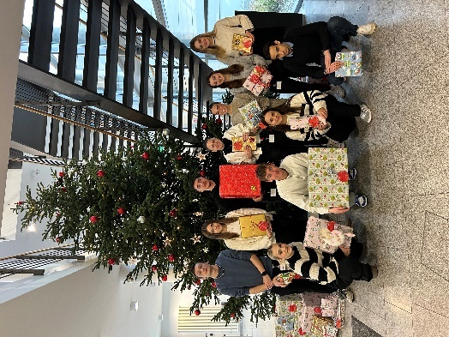  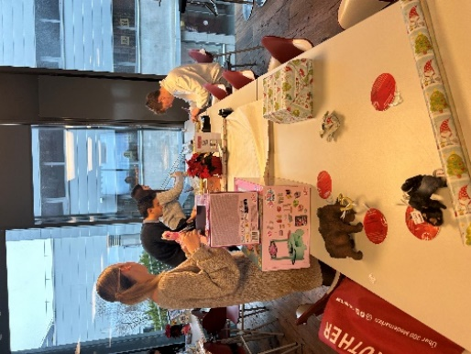  Image source: Würth Elektronik  Group photo of the Wishing Tree campaign team in front of the Christmas tree at Würth Elektronik in Waldenburg. | 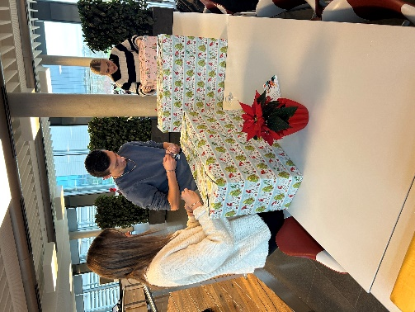  Image source: Würth Elektronik  The Young Talents from Würth Elektronik have collected donations and bought the presents, which now just need to be wrapped. | Image source: Würth Elektronik  The team of trainees and students from Würth Elektronik packs the presents for the Wishing Tree campaign.

About the Würth Elektronik eiSos Group
Würth Elektronik eiSos Group is a manufacturer of electronic and electromechanical components for the electronics industry and a technology company that spearheads pioneering electronic solutions. Würth Elektronik eiSos is one of the largest European manufacturers of passive components and is active in 50 countries. Production sites in Europe, Asia and North America supply a growing number of customers worldwide.
The product range includes EMC components, inductors, transformers, RF components, varistors, capacitors, resistors, quartz crystals, oscillators, power modules, Wireless Power Transfer, LEDs, sensors, radio modules, connectors, power supply elements, switches, push-buttons, connection technology, fuse holders and solutions for wireless data transmission. The portfolio is complemented by customized solutions.

The unrivaled service orientation of the company is characterized by the availability of all catalog components from stock without minimum order quantity, free samples and extensive support through technical sales staff and selection tools.
Würth Elektronik is part of the Würth Group, the global market leader in the development, production, and sale of fastening and assembly materials, and employs 7,900 people. In 2023, the Würth Elektronik Group generated sales of 1.24 Billion Euro.
Würth Elektronik: more than you expect!
Further information at www.we-online.com

Further information:  Würth Elektronik eiSos GmbH & Co. KG  Sarah Hurst  Clarita-Bernhard-Strasse 9  81249 Munich  Germany  Phone: +49 7942 945-5186  E-mail: sarah.hurst@we-online.de  www.we-online.com | Press contact:  HighTech communications GmbH  Brigitte Basilio  Brunhamstrasse 21  81249 Munich  Germany  Phone: +49 89 500778-20  E-mail: b.basilio@htcm.de  www.htcm.de

