PRESS RELEASE
Würth Elektronik now an Infineon ‘Preferred Partner’
The Right Components for Your IC
Waldenburg (Germany), March 13, 2025 – Würth Elektronik, one of the leading manufacturers of electronic and electromechanical components, is broadening its collaboration with semiconductor manufacturers. The company, which has collaborated with the major industry players for many years, was recently recognized by Infineon as a ‘Preferred Partner’. Developers benefit from this partnership by gaining access to over 480 reference designs featuring Infineon chips and compatible components on the Würth Elektronik website.
“Today, ICs and passive components complement each other to form a functional whole in almost every sizeable electronic assembly,” Alexander Gerfer, CTO at Würth Elektronik eiSos explains. “So, it’s only logical that we closely collaborate with IC manufacturers like Infineon to offer developers practical turnkey solutions.” The Preferred Partnership status underlines Infineon's trust in the quality and reliability of the Würth Elektronik products. As a Preferred Partner, Würth Elektronik also gains access to exclusive internal resources of the semiconductor manufacturer.
Practical benefits for developers
The partnership provides real added value for developers: A dedicated section on the Würth Elektronik website provides access to all reference designs for which Infineon uses Würth Elektronik components. The filtering functions allows users to select a reference design optimized for their application. Each design includes a comprehensive description, detailed circuit diagrams, an IC specification, and a bill of materials for the suitable Würth Elektronik components. Developers can request these components as free lab samples or access additional specs via the REDEXPERT simulation platform. The database currently includes over 25,000 Würth Elektronik components.
Shortcut to your first prototype
“Reference designs from many other IC manufacturers, created using our components, are also quickly and easily available on our website,” Gerfer stresses. “They guide you directly from concept to the first prototype.” Developers can find a working circuit for many standard applications, such as motor control or converters, and customize it as needed – with just a few clicks. REDEXPERT helps optimize the dimensioning process and provides valuable support for SMEs that often lack development resources.”
Besides reference designs, Würth Elektronik also offers a wealth of application notes on its website, developed in collaboration with IC manufacturers, as well as information on upcoming events.
The Infineon reference designs are available at:
https://www.we-online.com/en/components/icref/infineon-technologies
And here’s an overview of all IC partners and reference designs:
https://www.we-online.com/en/components/icref

Available images
The following images can be downloaded from the Internet in printable quality: https://kk.htcm.de/press-releases/wuerth/
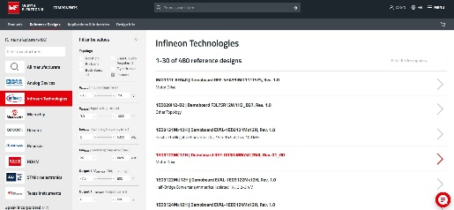Image source: Würth Elektronik
Free selection: Developers can use various search and filter functions to select the reference design that’s right for them.

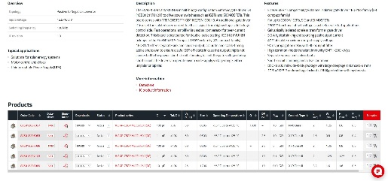Image source: Würth Elektronik
All information at a glance: Besides describing the IC and application, the reference design pages feature an interactive bill of materials with a link to the REDEXPERT simulation platform.

About the Würth Elektronik eiSos Group
Würth Elektronik eiSos Group is a manufacturer of electronic and electromechanical components for the electronics industry and a technology company that spearheads pioneering electronic solutions. Würth Elektronik eiSos is one of the largest European manufacturers of passive components and is active in 50 countries. Production sites in Europe, Asia and North America supply a growing number of customers worldwide.
The product range includes passive components, power modules, digital isolators, optoelectronics, electromechanical components, thermal management solutions, sensors and wireless modules. The portfolio is rounded off by customer-specific solutions.
The unrivaled service orientation of the company is characterized by the availability of all catalog components from stock without minimum order quantity, free samples and extensive support through technical sales staff and selection tools.
Würth Elektronik is part of the Würth Group, the global market leader in the development, production, and sale of fastening and assembly materials, and employs around 7,500 people. The Würth Elektronik Group generated sales of 1 Billion Euro (all figures according to preliminary results for 2024).
Würth Elektronik: more than you expect!
Further information at www.we-online.com

Further information:  Würth Elektronik eiSos GmbH & Co. KG  Sarah Hurst  Clarita-Bernhard-Strasse 9  81249 Munich  Germany  Phone: +49 7942 945-5186  E-mail: sarah.hurst@we-online.de  www.we-online.com | Press contact:  HighTech communications GmbH  Brigitte Basilio  Brunhamstrasse 21  81249 Munich  Germany  Phone: +49 89 500778-20  E-mail: b.basilio@htcm.de  www.htcm.de

