PRESS RELEASE
Würth Elektronik receives award for family friendliness: “familyNET 4.0”
Excellent corporate culture
Waldenburg (Germany), December 12, 2024 – An attractive workplace that combines career and family in an exemplary manner: Würth Elektronik eiSos is honored to receive the prestigious “familyNET 4.0” award in the “Family friendliness and health” category for its modern and family-friendly corporate culture. The award recognizes companies that promote a modern corporate culture through innovative concepts and actively support the compatibility of work and private life.
The award was presented for the sixth time by the Baden-Württemberg Ministry of Economic Affairs, Labor and Tourism and the Bildungswerk der Baden-Württembergischen Wirtschaft (BIWE) in the two categories “Family friendliness and health” and “Leadership, personal development and diversity”. The state-wide competition, familyNET 4.0 - The competition for a modern corporate culture,” recognizes companies that use innovative, sustainable, and digital concepts to shape a future-proof corporate culture, and thus strengthen the supply of skilled workers in the long term.
An attractive employer for all circumstances
Würth Elektronik eiSos has impressed the jury with its comprehensive offering, which sets new standards in employer responsibility. Flexible working time models, mobile working throughout the EU, company-supported childcare, versatile health management and individual advice on different phases of life are just some of the measures that focus on the needs of employees. “With its vision of being an attractive employer for all life situations and its mission to create flexible and family-friendly offerings, Würth Elektronik eiSos shows what modern employer responsibility looks like,” says the laudation.
An award with a signal effect
This year, the organizers selected two companies from 24 applications in the “Family Friendliness and Health” category - including Würth Elektronik eiSos. “We are proud of this award, which confirms our commitment to a sustainable and employee-oriented corporate culture,” says Janina Stolla-Braun, member of the project team Lebenslagen, who accepted the award at a festive awards ceremony on November 28. “This recognition shows that we are on the right track with our work-life balance measures for our employees.” The organizers are sending out a clear signal with this annual competition: Employers who focus on humanity and modern concepts are the key to a sustainable economy.

Available images
The following images can be downloaded from the Internet in printable quality: https://kk.htcm.de/press-releases/wuerth/
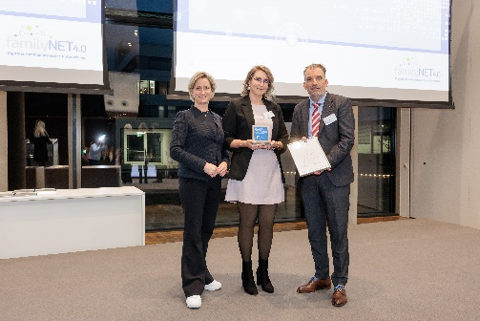Image source: BBQ-Bildung und Berufliche Qualifizierung gGmbH  Presentation of the “familyNET 4.0” award: (from left) Dr. Nicole Hoffmeister-Kraut, Minister of Economic Affairs, Labour and Tourism Baden-Württemberg, Janina Stolla-Braun, Project Team Life Situations at Würth Elektronik eiSos, and Stefan Küpper, Spokesman of the Management Board at Bildungswerk der Baden-Württembergischen Wirtschaft e. V. | 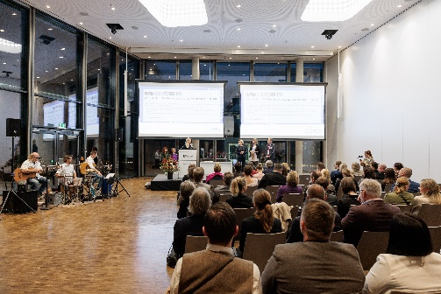Image source: BBQ Bildung und Berufliche Qualifizierung gGmbH  Modern employer responsibility: The “familyNET 4.0” award, presented in the category “Family friendliness and health”, confirms the successful work-life balance at Würth Elektronik.

About the Würth Elektronik eiSos Group
Würth Elektronik eiSos Group is a manufacturer of electronic and electromechanical components for the electronics industry and a technology company that spearheads pioneering electronic solutions. Würth Elektronik eiSos is one of the largest European manufacturers of passive components and is active in 50 countries. Production sites in Europe, Asia and North America supply a growing number of customers worldwide.
The product range includes EMC components, inductors, transformers, RF components, varistors, capacitors, resistors, quartz crystals, oscillators, power modules, Wireless Power Transfer, LEDs, sensors, radio modules, connectors, power supply elements, switches, push-buttons, connection technology, fuse holders and solutions for wireless data transmission. The portfolio is complemented by customized solutions.

The unrivaled service orientation of the company is characterized by the availability of all catalog components from stock without minimum order quantity, free samples and extensive support through technical sales staff and selection tools.
Würth Elektronik is part of the Würth Group, the global market leader in the development, production, and sale of fastening and assembly materials, and employs 7,900 people. In 2023, the Würth Elektronik Group generated sales of 1.24 Billion Euro.
Würth Elektronik: more than you expect!
Further information at www.we-online.com

Further information:  Würth Elektronik eiSos GmbH & Co. KG  Sarah Hurst  Clarita-Bernhard-Strasse 9  81249 Munich  Germany  Phone: +49 7942 945-5186  E-mail: sarah.hurst@we-online.de  www.we-online.com | Press contact:  HighTech communications GmbH  Brigitte Basilio  Brunhamstrasse 21  81249 Munich  Germany  Phone: +49 89 500778-20  E-mail: b.basilio@htcm.de  www.htcm.de

