PRESS RELEASE

Würth Elektronik at DLD 2025
The potential of CO₂-neutral greenhouses to feed the world
Waldenburg, Munich (Germany), January 27, 2025 – Alexander Gerfer, CTO of the Würth Elektronik eiSos Group and Ryan Archer, Co-Founder and COO of Horizon Growers, presented the latest developments in vertical farming at the DLD Conference in Munich on 17 January 2025. The discussion, moderated by FOCUS editor-in-chief Franziska Reich, posed the provocative question: ‘Can the CO₂-neutral greenhouse feed the world?’
Magnificent plant growth can be seen right in front of the DLD stage – Alexander Gerfer, has once again brought something special for the 20th anniversary of the digital conference: a ‘Breeding Station’ for the pre-cultivation of cuttings and seedlings, which, under controlled light and nutrient supply, is intended to make an important contribution to local and sustainable indoor farming. The station's extensive measurement technology even allows it to learn from the system, including using AI approaches. This new project from the component manufacturer was developed in collaboration with Bürkert Fluid Systems.
Continuous optimization of horticulture LEDs
Würth Elektronik's commitment to controlled environment agriculture (CEA) is nothing new: as part of the development of horticulture LEDs, the company has been researching specific light recipes that control plant growth in a targeted manner for years. Precisely defined light frequencies and illumination rhythms promote faster and more effective root formation in cuttings, reduce failure rates and increase productivity in indoor farming systems. Every plant has its ideal light recipe for optimal growth.
Local production instead of imports
‘The import rate of tomatoes in Germany is almost identical to that of the United Arab Emirates,’ says Ryan Archer, COO of Horizon Growers, surprising everyone with this statement. This start-up team was previously responsible for developing and operating one of the largest indoor farms of the Middle East in the desert state. Archer does not consider long transport routes for the food supply to be sustainable. He therefore advocates, just like Würth Elektronik, for consumer-oriented production in indoor farms in Germany.
Synergies are crucial for efficiency
Gerfer and Archer also agree on another key point: energy efficiency and synergies are crucial to the successful implementation of indoor farming in Germany. The vision: CEA farms in clusters that work with renewable energy sources and CO₂-intensive producers. The industrial companies can provide large amounts of waste heat and CO₂ emissions for plant breeding, while the CEA farms serve as CO₂ sinks. This would make a CO2-neutral greenhouse possible.
Together for success
One thing became particularly clear during the panel discussion: a successful, consumer-oriented and sustainable food supply will only be possible through new partnerships – partnerships between high-tech companies, partnerships between industry and agriculture. ‘For the breeding station, we are working with the fluid system specialist Bürkert,’ explains Alexander Gerfer. ’Now we are considering, together with Horizon Growers, how this system can form the basis for future net-zero greenhouses. As a responsible company, we are helping to turn ideas into reality.’

Available images
The following images can be downloaded from the Internet in printable quality: https://kk.htcm.de/press-releases/wuerth/
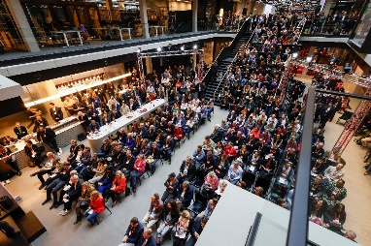  Image source: Michaela Stache for DLD / Hubert Burda Media  DLD 2025: current challenges and opportunities of our time will be discussed at the international conference in Munich. | 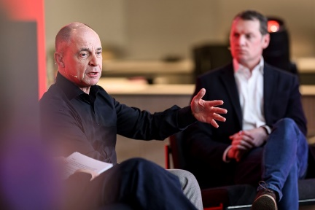  Image source: Philipp Guelland for DLD / Hubert Burda Media  Alexander Gerfer, CTO Würth Elektronik eiSos Group: “As a component manufacturer, we are helping to turn ideas into reality.”

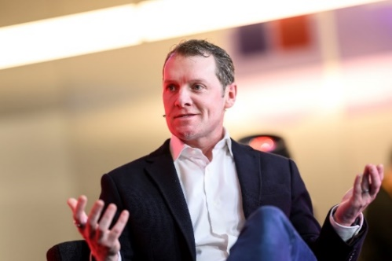  Image source: Philipp Guelland for DLD / Hubert Burda Media  Ryan Archer, Co-Founder and COO of Horizon Growers: has developed one of the largest indoor farms in the Middle East. | 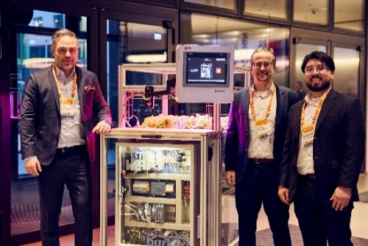  Image source: Dominik Gigler for DLD / Hubert Burda Media  Breeding Station: The system for the pre-cultivation of cuttings and seedlings under controlled light and nutrient supply was developed by Würth Elektronik together with Bürkert Fluid Systems System.  From left to right: Harun Özgür, Division Manager Optoelectronics at Würth Elektronik eiSos, Johann Waldherr Business Development Manager Electronic Power & Lighting Solutions at Würth Elektronik eiSos, Carlos Roberto Hernández Gómez, Product Manager Optoelectronics at Würth Elektronik eiSos.

Available videos
You can find the complete panel talk on YouTube:
https://www.youtube.com/watch?v=Bf-ROXtM_mw
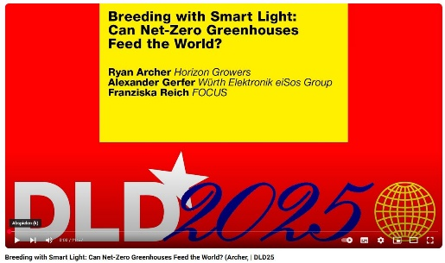
Quelle: DLD
Breeding with Smart Light: Can Net-Zero Greenhouses Feed the World?

About Horizon Growers
Horizon Growers is a Munich-based developer of sustainable, high-tech indoor farms. Horizon Growers believes that the world needs shorter, stable and sustainable supply chains to address the unprecedented global challenges in food production. Their mission is to develop high-tech, decarbonizing indoor farms to grow better produce closer to people.
Horizon Growers' developments use waste heat from industry, such as large manufacturers and data centers, to enable food production independent of climate conditions. By combining waste heat recovery, renewable energy and CO2 capture techniques, they can enable sustainable food production close to consumers.
By developing high-tech indoor farms in collaboration with strategic partners, Horizon Growers can utilize abundant heat and CO2 emissions to grow fresh produce close to people with the lowest carbon footprint.
Further information at https://www.horizongrowers.com

About the Würth Elektronik eiSos Group
Würth Elektronik eiSos Group is a manufacturer of electronic and electromechanical components for the electronics industry and a technology company that spearheads pioneering electronic solutions. Würth Elektronik eiSos is one of the largest European manufacturers of passive components and is active in 50 countries. Production sites in Europe, Asia and North America supply a growing number of customers worldwide.
The product range includes EMC components, inductors, transformers, RF components, varistors, capacitors, resistors, quartz crystals, oscillators, power modules, Wireless Power Transfer, LEDs, sensors, radio modules, connectors, power supply elements, switches, push-buttons, connection technology, fuse holders and solutions for wireless data transmission. The portfolio is complemented by customized solutions.
The unrivaled service orientation of the company is characterized by the availability of all catalog components from stock without minimum order quantity, free samples and extensive support through technical sales staff and selection tools.
Würth Elektronik is part of the Würth Group, the global market leader in the development, production, and sale of fastening and assembly materials, and employs 7,900 people. In 2023, the Würth Elektronik Group generated sales of 1.24 Billion Euro.
Würth Elektronik: more than you expect!
Further information at www.we-online.com

Further information:  Würth Elektronik eiSos GmbH & Co. KG  Sarah Hurst  Clarita-Bernhard-Strasse 9  81249 Munich  Germany  Phone: +49 7942 945-5186  E-mail: sarah.hurst@we-online.de  www.we-online.com | Press contact:  HighTech communications GmbH  Brigitte Basilio  Brunhamstrasse 21  81249 Munich  Germany  Phone: +49 89 500778-20  E-mail: b.basilio@htcm.de  www.htcm.de

