PRESS RELEASE
Würth Elektronik expands its range of inductors
to include Power Molded Flat-Wire Inductors
For High Switching Frequencies and Output Currents
Waldenburg (Germany), April 23, 2025 – Würth Elektronik introduces its new molded flat-wire inductor with the designation WE-PMFI. The compact inductor measures just 2.0 × 1.6 × 1.0 mm in its smallest package. It also impresses with an exceptionally low resistance (R_{DC} from 4.8 mΩ), an operating voltage of up to 48 V, as well as an extended temperature range from -55°C to +150°C, making it particularly suitable for DC/DC converter assemblies in compact applications that require high output currents and switching frequencies exceeding one megahertz.
Flat-wire technology offers a host of advantages for inductors: they are mechanically more robust as well as optimized heat dissipation. The wire shape utilizes the winding area more efficiently, allowing for higher inductance values in the same package size as compared to round wire. Flat-wire windings also offer a larger cross-sectional area, thus reducing resistance and I²R losses. Eddy current losses, especially in high-frequency applications, are also lower in a flat-wire inductor compared to the round-wire version. These properties have enabled Würth Elektronik to develop a new generation of components that are more compact, temperature-resistant, and far more energy-efficient. They open up new design options for developers.
Minimum dimensions, maximum efficiency
This small and highly efficient inductor is ideal for powering CPUs and RAM in portable electronic devices, such as smartphones and tablets. Measurements with comparable components on the market have shown that the WE-PMFI has 50% lower DC resistance, 40% higher rated current, and 30% higher saturation current.
Available from 100 nH to 4.7 µH
The new molded flat-wire inductor is now available in a broad range of inductance values from 100 nH to 4.7 µH. As with all Würth Elektronik components, free laboratory samples of the new flat-wire inductor can also be ordered.

Available images
The following images can be downloaded from the Internet in printable quality: https://kk.htcm.de/press-releases/wuerth/
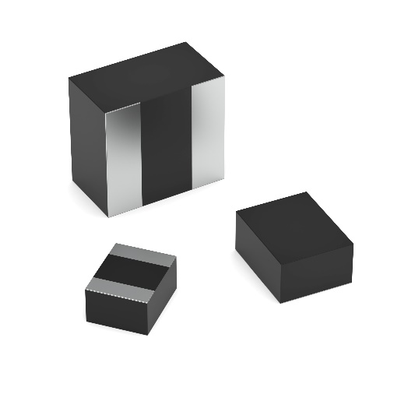
Image source: Würth Elektronik
Very small and efficient: WE-PMFI

Available video material
The following video material can be viewed on our YouTube channel:
https://youtube.com/shorts/l3aFjVe94z0
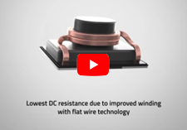
Source: Würth Elektronik
Flat wire coil: Power Molded Flat Wire Inductor

About the Würth Elektronik eiSos Group
Würth Elektronik eiSos Group is a manufacturer of electronic and electromechanical components for the electronics industry and a technology company that spearheads pioneering electronic solutions. Würth Elektronik eiSos is one of the largest European manufacturers of passive components and is active in 50 countries. Production sites in Europe, Asia and North America supply a growing number of customers worldwide.
The product range includes passive components, power modules, digital isolators, optoelectronics, electromechanical components, thermal management solutions, sensors and wireless modules. The portfolio is rounded off by customer-specific solutions.
The unrivaled service orientation of the company is characterized by the availability of all catalog components from stock without minimum order quantity, free samples and extensive support through technical sales staff and selection tools.
Würth Elektronik is part of the Würth Group, the global market leader in the development, production, and sale of fastening and assembly materials, and employs around 7,500 people. The Würth Elektronik Group generated sales of 1 Billion Euro (all figures according to preliminary results for 2024).
Würth Elektronik: more than you expect!
Further information at www.we-online.com

Further information:  Würth Elektronik eiSos GmbH & Co. KG  Sarah Hurst  Clarita-Bernhard-Strasse 9  81249 Munich  Germany  Phone: +49 7942 945-5186  E-mail: sarah.hurst@we-online.de  www.we-online.com | Press contact:  HighTech communications GmbH  Brigitte Basilio  Brunhamstrasse 21  81249 Munich  Germany  Phone: +49 89 500778-20  E-mail: b.basilio@htcm.de  www.htcm.de

