PRESS RELEASE
First blood donation campaign at Würth Elektronik is a great success
Employees Share the Gift of Life
Waldenburg (Germany), January 21, 2025 – At the end of 2024, Würth Elektronik eiSos demonstrated how social responsibility can be successfully integrated into everyday work life. On December 5, the company organized a blood drive within the headquarters in Waldenberg, Germany. In cooperation with the German Red Cross (GRC) blood donation service Baden-Württemberg/Hesse, 66 employees came to the company site in Waldenburg to donate blood. Impressively, 35 employees demonstrated remarkable strength by making their very first blood donation- a power act of generosity.
“At Würth Elektronik, social commitment is a central component of our corporate culture. The blood donation campaign shows how easy it can be to do good in everyday life,” explains Sara Leidig, organizer of the blood donation campaign at Würth Elektronik eiSos. The internal “Awareness” project group implemented the campaign together with a mobile team from the GRC blood donation service. Thanks to targeted communication and smooth organization, employees were able to participate easily. The initiative was not only a success for the GRC blood donation service, but also for the team spirit within the company. Many participants pledged to donate blood regularly in future.
Blood donations: An indispensable contribution
The need for such campaigns is undisputed. More than 15,000 blood donations are needed in Germany every day. Three life-saving preparations can be obtained from just one donation - red blood cells, platelets, and plasma. “The high level of participation shows that our employees are willing to take on responsibility and make an important contribution to society,” emphasizes Leidig.
Social responsibility firmly anchored
Würth Elektronik eiSos actively promotes a corporate culture that focuses on a sense of community and responsibility. “We want to make it easier for our employees to take on social responsibility and shape the working environment in such a way that a sense of community is lived,” explains Leidig. For this reason, the blood donation campaign is not intended to be a one-off initiative, but rather the prelude to further projects of this nature.

Available images
The following images can be downloaded from the Internet in printable quality: https://kk.htcm.de/press-releases/wuerth/
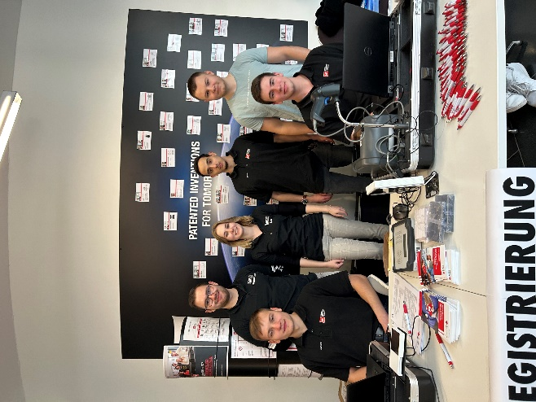 Source: Würth Elektronik
Social commitment on the job: The “Awareness” project group organized the blood donation campaign.

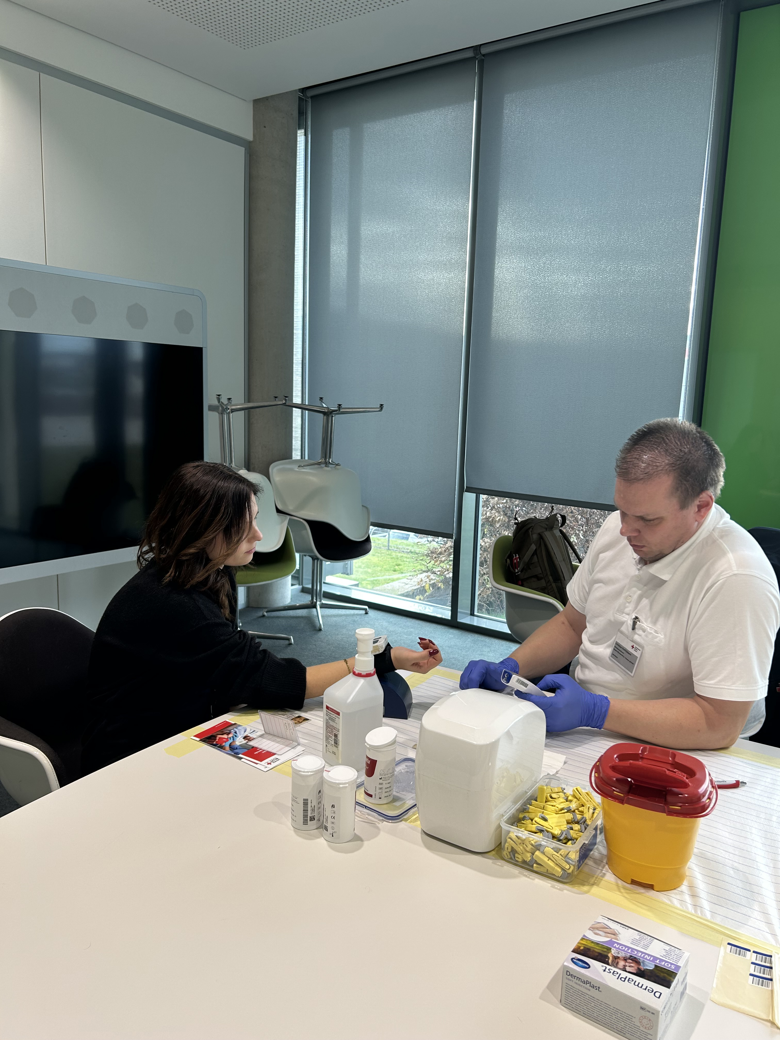  Source: Würth Elektronik  Professionals on site: the mobile team of the GRC blood donation service. | 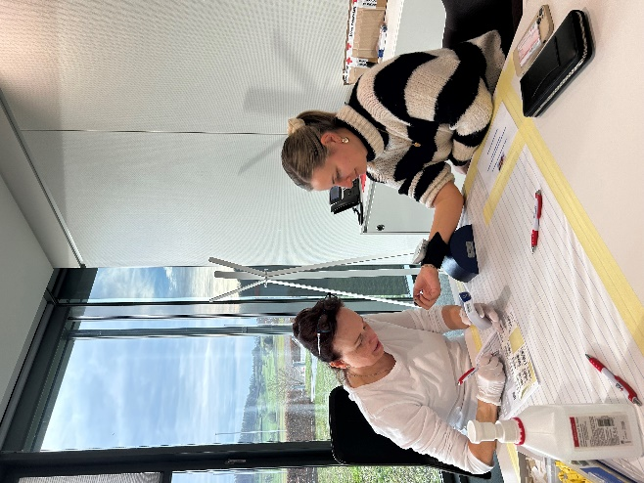  Source: Würth Elektronik  Check-up at the workplace: donors' vital signs are checked before donating blood.

About the Würth Elektronik eiSos Group
Würth Elektronik eiSos Group is a manufacturer of electronic and electromechanical components for the electronics industry and a technology company that spearheads pioneering electronic solutions. Würth Elektronik eiSos is one of the largest European manufacturers of passive components and is active in 50 countries. Production sites in Europe, Asia and North America supply a growing number of customers worldwide.
The product range includes EMC components, inductors, transformers, RF components, varistors, capacitors, resistors, quartz crystals, oscillators, power modules, Wireless Power Transfer, LEDs, sensors, radio modules, connectors, power supply elements, switches, push-buttons, connection technology, fuse holders and solutions for wireless data transmission. The portfolio is complemented by customized solutions.
The unrivaled service orientation of the company is characterized by the availability of all catalog components from stock without minimum order quantity, free samples and extensive support through technical sales staff and selection tools.
Würth Elektronik is part of the Würth Group, the global market leader in the development, production, and sale of fastening and assembly materials, and employs 7,900 people. In 2023, the Würth Elektronik Group generated sales of 1.24 Billion Euro.
Würth Elektronik: more than you expect!
Further information at www.we-online.com

Further information:  Würth Elektronik eiSos GmbH & Co. KG  Sarah Hurst  Clarita-Bernhard-Strasse 9  81249 Munich  Germany  Phone: +49 7942 945-5186  E-mail: sarah.hurst@we-online.de  www.we-online.com | Press contact:  HighTech communications GmbH  Brigitte Basilio  Brunhamstrasse 21  81249 Munich  Germany  Phone: +49 89 500778-20  E-mail: b.basilio@htcm.de  www.htcm.de

