PRESS RELEASE
Würth Elektronik renews strategic partnership with Centech in Montreal
Innovation incubator
Watertown (USA), Montreal (Kanada), March 6, 2025 – Würth Elektronik, a global leader in electronic and electromechanical components, is proud to announce an additional two-year partnership with Centech, a renowned university business incubator based in Montreal, Canada. This renewed collaboration aims to support the growth of emerging technology start-ups by combining Centech's entrepreneurial ecosystem with Würth Elektronik's expertise and resources.
Centech specializes in fostering high-potential technological innovation projects originating from science and engineering disciplines. Over the past 25 years, the incubator has helped bring groundbreaking ideas to market, contributing to the creation of over 1,500 jobs by graduate companies in just the last five years. By offering entrepreneurs access to resources, tools, and industry connections, Centech provides a comprehensive platform for conceptualizing, developing, and commercializing innovative products.
Through this partnership, Würth Elektronik will serve as a key supporter and champion Centech's mission to foster the next generation of technology leaders. As part of the agreement, Würth Elektronik will supply a state-of-the-art testing rack equipped with complimentary samples of electronic and electromechanical components. This advanced equipment will enable entrepreneurs to prototype and refine their technologies with precision and efficiency.
In addition to technical support, Würth Elektronik will provide expertise in electronic component selection and board layout design. Entrepreneurs will gain direct access to Würth Elektronik’s global network of knowledge, empowering them to develop robust, market-ready solutions that meet the highest industry standards.
This partnership enables entrepreneurs to access cutting-edge components and technical resources while benefiting from Würth Elektronik’s design expertise, which ensures optimized performance and reliability of electronic systems. The collaboration strengthens the Montreal technology ecosystem, fostering innovation and job creation, and reflects Würth Elektronik’s commitment to nurturing the future of technological advancements. This strategic collaboration underscores Würth Elektronik's mission to drive progress in the electronics industry while supporting the growth of local and global innovation ecosystems. Together, Würth Elektronik and Centech are committed to enabling breakthroughs that will shape the future of technology.

Available images
The following images can be downloaded from the Internet in printable quality: https://kk.htcm.de/press-releases/wuerth/
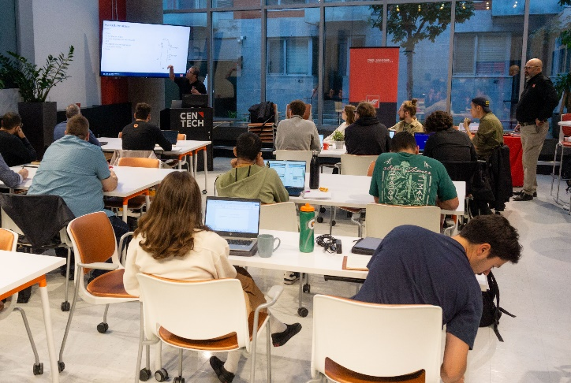Image source: Würth Elektronik
Würth Elektronik trains young developers at the Centech start-up center.

About the Würth Elektronik eiSos Group
Würth Elektronik eiSos Group is a manufacturer of electronic and electromechanical components for the electronics industry and a technology company that spearheads pioneering electronic solutions. Würth Elektronik eiSos is one of the largest European manufacturers of passive components and is active in 50 countries. Production sites in Europe, Asia and North America supply a growing number of customers worldwide.
The product range includes passive components, power modules, digital isolators, optoelectronics, electromechanical components, thermal management solutions, sensors and wireless modules. The portfolio is rounded off by customer-specific solutions.
The unrivaled service orientation of the company is characterized by the availability of all catalog components from stock without minimum order quantity, free samples and extensive support through technical sales staff and selection tools.
Würth Elektronik is part of the Würth Group, the global market leader in the development, production, and sale of fastening and assembly materials, and employs around 7,500 people. The Würth Elektronik Group generated sales of 1 Billion Euro (all figures according to preliminary results for 2024).
Würth Elektronik: more than you expect!
Further information at www.we-online.com

Further information:  Wurth Electronics Midcom, Inc.  Amelia Thompson  121 Airport Drive  PO Box 1330  Watertown, SD 57201 USA  Phone: +1 605 886 4385  Toll-free (in the U.S.):  Phone: +1 800 643 2661  E-mail: amelia.thompson@we-online.com  www.we-online.com | Press contact:  HighTech communications GmbH  Brigitte Basilio  Brunhamstrasse 21  81249 Munich  Germany  Phone: +49 89 500778-20  E-mail: b.basilio@htcm.de  www.htcm.de

