PRESS RELEASE

Würth Elektronik employees donate 1,000 euros
Late Christmas present for the Westernach community kindergarten
Waldenburg (Germany), February 6, 2025 – A cheerful and colorful start to the new year awaits the children of the Westernach community kindergarten. Thanks to a generous donation of EUR 1,000, collected by the employees of Würth Elektronik eiSos GmbH & Co. KG, the children will soon be able to call a long-awaited ball pool their own. The donation is the result of a pre-Christmas, after-work event at the company headquarters in Waldenburg. The internal Christmas market was organized by the “eiSos Spirit” project group, which oversees corporate culture.
The children and teachers have been eagerly awaiting the “belated Christmas present.” On January 23, Sebastian Valet, Member of the Management Board at Würth Elektronik eiSos GmbH & Co. KG, and Sina Jary, member of the “eiSos Spirit” project group, presented a donation check for EUR 1,000. This money will go directly towards the purchase of a new ball pit, which will make everyday life in the kindergarten even more colorful and cheerful.
“I am delighted that we can make a contribution to the children in our immediate neighborhood through the commitment of our employees,” says Sebastian Valet. “This social interaction is an essential part of our corporate culture - that's what characterizes the 'eiSos spirit'.”
A Christmas market with heart
The Christmas market at the Waldenburg site has long since become a firm fixture in the annual calendar - and was also a complete success in 2024. The pre-Christmas, after-work event not only offered employees and their families an opportunity to enjoy the Advent season in a relaxed atmosphere, but also partake in a charitable purpose. Dedicated colleagues provided homemade treats, such as mulled wine, punch, cookies, grilled sausages, and crêpes. An arts and crafts market with handmade gift ideas rounded off the offerings. Donations were collected under the motto “Pay what it's worth to you”, which the management rounded up to 1,000 euros.
Elisa Fromm, head of the community kindergarten, was delighted: “The commitment of the Würth Elektronik employees is truly admirable. With their donation, they are not only making the children happy, but also our entire team. The new ball pool will be a highlight for our little ones and a valuable support in their everyday educational activities.”

Available images
The following images can be downloaded from the Internet in printable quality: https://kk.htcm.de/press-releases/wuerth/
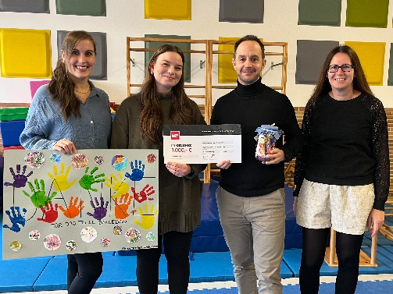Image source: Würth Elektronik  A colorful start to the kindergarten year: Würth Elektronik donated EUR 1,000 for a new ball pool. At the donation handover (from left to right):  Elisa Fromm and Pia Bögl from the Westernach community kindergarten, Sebastian Valet, member of the management of Würth Elektronik eiSos GmbH & Co. KG, and Sina Jary from the “eiSos Spirit” project group. | 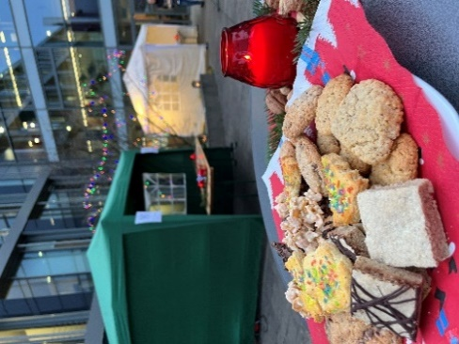Image source: Würth Elektronik  Christmas market with heart: Würth Elektronik employees organized the after-work event to collect donations.

About the Würth Elektronik eiSos Group
Würth Elektronik eiSos Group is a manufacturer of electronic and electromechanical components for the electronics industry and a technology company that spearheads pioneering electronic solutions. Würth Elektronik eiSos is one of the largest European manufacturers of passive components and is active in 50 countries. Production sites in Europe, Asia and North America supply a growing number of customers worldwide.
The product range includes EMC components, inductors, transformers, RF components, varistors, capacitors, resistors, quartz crystals, oscillators, power modules, Wireless Power Transfer, LEDs, sensors, radio modules, connectors, power supply elements, switches, push-buttons, connection technology, fuse holders and solutions for wireless data transmission. The portfolio is complemented by customized solutions.

The unrivaled service orientation of the company is characterized by the availability of all catalog components from stock without minimum order quantity, free samples and extensive support through technical sales staff and selection tools.
Würth Elektronik is part of the Würth Group, the global market leader in the development, production, and sale of fastening and assembly materials, and employs 7,900 people. In 2023, the Würth Elektronik Group generated sales of 1.24 Billion Euro.
Würth Elektronik: more than you expect!
Further information at www.we-online.com

Further information:  Würth Elektronik eiSos GmbH & Co. KG  Sarah Hurst  Clarita-Bernhard-Strasse 9  81249 Munich  Germany  Phone: +49 7942 945-5186  E-mail: sarah.hurst@we-online.de  www.we-online.com | Press contact:  HighTech communications GmbH  Brigitte Basilio  Brunhamstrasse 21  81249 Munich  Germany  Phone: +49 89 500778-20  E-mail: b.basilio@htcm.de  www.htcm.de

