PRESS RELEASE
Deutsche Telekom IoT has incorporated GNSS modules from Würth Elektronik into its "IoT Digital Shelf”
Selection of Certified Hardware
Waldenburg (Germany), 15 April 2021—Deutsche Telekom IoT GmbH has certified the first two products from Würth Elektronik and added them to its “IoT Digital Shelf”. Here, the Telekom subsidiary gathers selected products on the market to complete its own portfolio with certified hardware enabling it to offer its customers end-to-end solutions. Localization technologies recommended by Deutsche Telekom IoT: the GNSS modules Erinome I and Erinome II.
The Erinome series exploits all four global navigation satellite systems at maximum speed for localization and navigation tasks: GPS, GLONASS, Galileo and BeiDou. Both modules can be operated in low-power mode—important for mobile and battery-powered devices. In addition to the usual UART interface, they offer I²C and SPI. Erinome I (18 mm × 18 mm × 6.4 mm) is the version with integrated antenna, Erinome II (7 mm × 7 mm × 1.6 mm) the version without. Detailed technical documentation is available for antenna selection, and Würth Elektronik provides advice free of charge here on request. An active antenna can also be offered, which already meets the IP66 protection class standard. The GNSS modules are available from stock without a minimum order quantity.
The two GNSS modules are also part of Deutsche Telekom IoT's "IoT Solution Optimizer". This tool allows companies to model and test digital twins of their IoT business ideas cost-effectively and without risk.
Easy to integrate
The various requirements of position-based applications can be met with the Würth Elektronik GNSS modules: Tracking of containers, navigation of agricultural machinery or drones, fleet management, cartography, geotagging cameras, monitoring animal transports or even referencing for international time synchronization.
Thanks to the evaluation kit, the Würth Elektronik Navigation Satellite Software (WENSS) tool and on-site consulting by engineers; even developers who want to integrate position determination into their product for the first time can soon achieve optimum results.

Available images
The following images can be downloaded from the Internet in printable quality: http://www.htcm.de/kk/wuerth
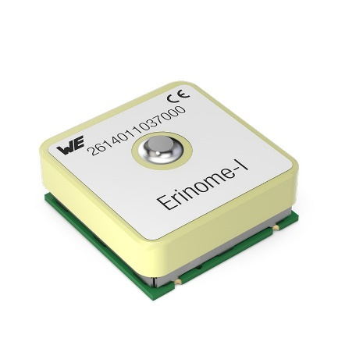  Image source: Würth Elektronik  Erinome I GNSS module (18 mm × 18 mm × 6.4 mm, with antenna) | 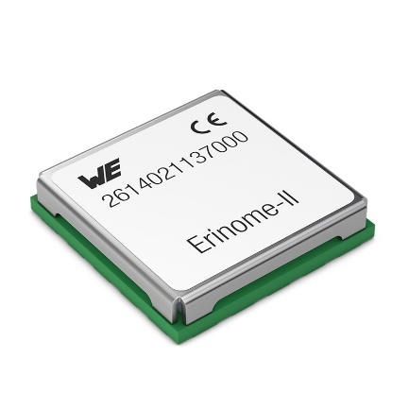  Image source: Würth Elektronik  Erinome II GNSS module (7 mm × 7 mm × 1.6 mm, without integrated antenna)

About the Würth Elektronik eiSos Group
Würth Elektronik eiSos Group is a manufacturer of electronic and electromechanical components for the electronics industry and a technology company that spearheads pioneering electronic solutions. Würth Elektronik eiSos is one of the largest European manufacturers of passive components and is active in 50 countries. Production sites in Europe, Asia and North America supply a growing number of customers worldwide.
The product range includes EMC components, inductors, transformers, RF components, varistors, capacitors, resistors, quartz crystals, oscillators, power modules, Wireless Power Transfer, LEDs, sensors, connectors, power supply elements, switches, push-buttons, connection technology, fuse holders and solutions for wireless data transmission.
The unrivaled service orientation of the company is characterized by the availability of all catalog components from stock without minimum order quantity, free samples and extensive support through technical sales staff and selection tools.
Through its technology partnership with the Audi Sport ABT Schaeffler Formula E Team and its support for the Formula Student racing series, the company demonstrates its innovative strength in eMobility
(www.we-speed-up-the-future.com).
Würth Elektronik is part of the Würth Group, the world market leader for assembly and fastening technology. The company employs 7,300 staff and generated sales of 823 million euros in 2020.
Würth Elektronik: more than you expect!
Further information at www.we-online.com

Further information:  Würth Elektronik eiSos GmbH & Co. KG  Sarah Hurst  Max-Eyth-Strasse 1  74638 Waldenburg  Germany  Phone: +49 7942 945-5186  E-mail: sarah.hurst@we-online.de  www.we-online.de | Press contact:  HighTech communications GmbH  Brigitte Basilio  Brunhamstrasse 21  81249 Munich  Germany  Phone: +49 89 500778-20  Telefax: +49 89 500778-77  E-mail: b.basilio@htcm.de  www.htcm.de

