PRESS RELEASE
Würth Elektronik extends its WE-SPXO quartz oscillator program
Robust Clock Signal Generators
Waldenburg (Germany), 3 February 2021—Würth Elektronik launches further WE-SPXO series quartz oscillators onto the market. The additions to the program include a new design with LVDS or LVPECL output signal plus 32.768 kHz oscillators. While the hermetically sealed oscillators were already outstandingly well specified for a wide range of industrial applications, the new arrivals are even more temperature-stable and also more precisely optimized for specific requirements.
The Würth Elektronik oscillators with LVDS or LVPECL output and frequencies from 100 to 156.25 MHz (models IQXO-618-18, IQXO-618-33, IQXO-623 and IQXO-624) are designed for applications with higher data rates: Gigabit Ethernet, Fibre Channel, PCI Express and SONET/SDH. The WE-SPXO oscillators—now available with differential LVDS or LVPECL output signal—feature improved jitter performance and higher noise immunity of the output signal. Their temperature range of -40 to +105°C also exceeds the normal standards.
Better than watch quartz
With the new 32.768 kHz oscillators (models CFPS-102, CFPS-104, CFPS-107, CFPS-109, IQXO-402, IQXO-404), Würth Elektronik offers electronic developers an alternative to watch quartz crystals. Available in three package sizes (3.2 × 2.5, 2.5 × 2.0 and 2.0 × 1.6 mm), the oscillators are very robust with a possible temperature range of -40 to +125°C and offer stability up to ±25 ppm. The big advantage compared to normal watch quartz crystals is their improved frequency stability over the temperature profile and thus also their accuracy. Unlike watch quartz, no additional oscillation circuitry is necessary. This saves design time and reduces the number of components on the PCB. Thanks to their accuracy and reliability, the new oscillators from Würth Elektronik are ideal for real-time clock microcontrollers and for all kinds of electronic devices in which the time of day is important—from laptops, smartphones and consumer electronics to washing machines, ATMs and industrial control systems.
All WE-SPXO quartz oscillator models are now available from stock without a minimum order quantity. Free samples can be requested.

Available images
The following images can be downloaded from the Internet in printable quality: http://www.htcm.de/kk/wuerth
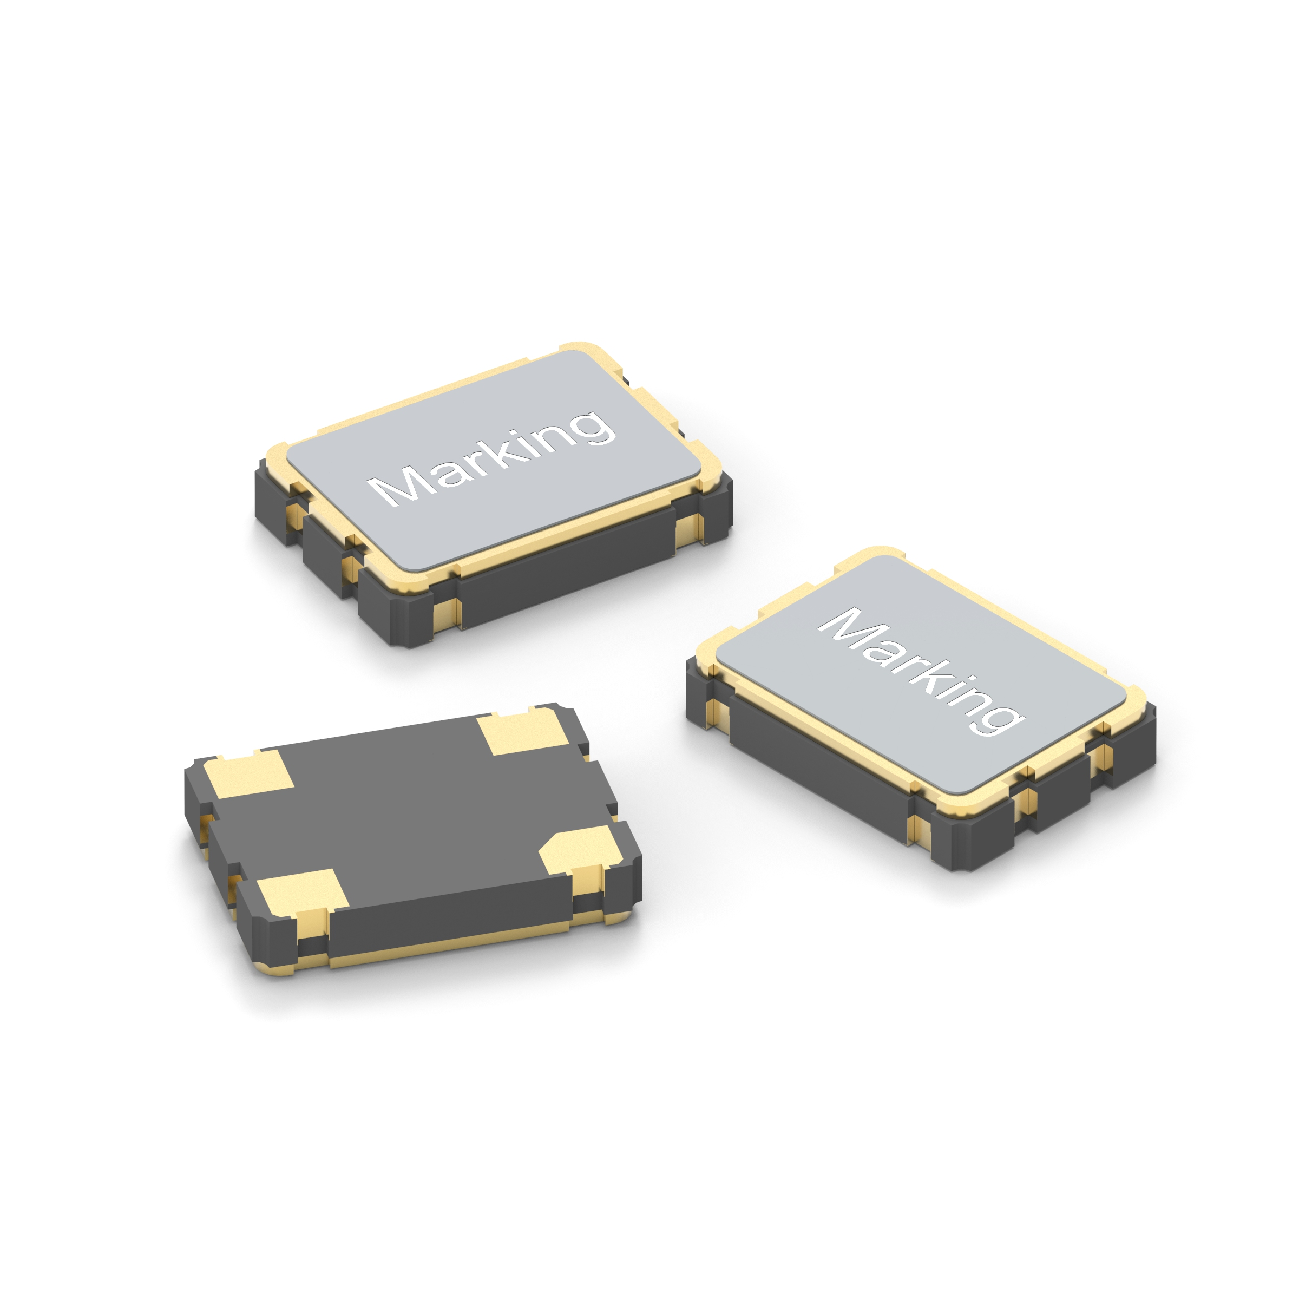
Image source: Würth Elektronik
WE-SPXO oscillators

About the Würth Elektronik eiSos Group
Würth Elektronik eiSos Group is a manufacturer of electronic and electromechanical components for the electronics industry and a technology company that spearheads pioneering electronic solutions. Würth Elektronik eiSos is one of the largest European manufacturers of passive components and is active in 50 countries. Production sites in Europe, Asia and North America supply a growing number of customers worldwide.
The product range includes EMC components, inductors, transformers, RF components, varistors, capacitors, resistors, quartz crystals, oscillators, power modules, Wireless Power Transfer, LEDs, sensors, connectors, power supply elements, switches, push-buttons, connection technology, fuse holders and solutions for wireless data transmission.
The unrivaled service orientation of the company is characterized by the availability of all catalog components from stock without minimum order quantity, free samples and extensive support through technical sales staff and selection tools.

Through its technology partnership with the Audi Sport ABT Schaeffler Formula E Team and its support for the Formula Student racing series, the company demonstrates its innovative strength in eMobility
(www.we-speed-up-the-future.com).
Würth Elektronik is part of the Würth Group, the world market leader for assembly and fastening technology. The company employs 7,300 staff and generated sales of 822 million euros in 2019.
Würth Elektronik: more than you expect!
Further information at www.we-online.com

Further information:  Würth Elektronik eiSos GmbH & Co. KG  Sarah Hurst  Max-Eyth-Strasse 1  74638 Waldenburg  Germany  Phone: +49 7942 945-5186  E-mail: sarah.hurst@we-online.de  www.we-online.de | Press contact:  HighTech communications GmbH  Brigitte Basilio  Brunhamstrasse 21  81249 Munich  Germany  Phone: +49 89 500778-20  Telefax: +49 89 500778-77  E-mail: b.basilio@htcm.de  www.htcm.de

