PRESS RELEASE
Würth Elektronik offers free EMI filter design tool
Simulation platform REDEXPERT extended
Waldenburg (Germany), January 13, 2022—REDEXPERT from Würth Elektronik is a precise simulation platform based on measured values that supports the component manufacturer's customers in selecting suitable components. Now, with the EMI Filter Designer, a user-friendly function for developing filters against electromagnetic interference has been added. In the first version of the tool, which will be continuously expanded, discrete low-pass EMI filters for conducted differential interference can be developed, such as those needed for DC-DC converters.
After entering the input specifications, the REDEXPERT EMI Filter Designer calculates the optimal capacitors and inductors and outputs a suitable circuit topology. This allows the user to directly benefit from the know-how of the EMC consultants at Würth Elektronik who designed this tool. The EMI Filter Designer is available for free use at http://redexpert.we-online.com. Free samples of the suitable components determined with the tool can be ordered directly from this for prototyping.

Available image material
The following image material is available for download in printable form on the Internet: https://kk.htcm.de/press-releases/wuerth/
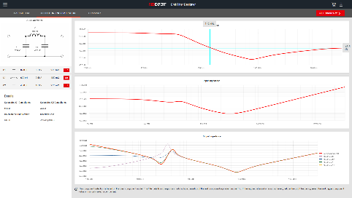  Image source: Würth Elektronik  REDEXPERT EMI Filter Designer: The behavior of the filter is simulated | 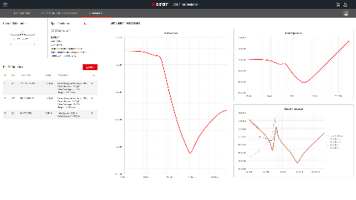  Image source: Würth Elektronik  Summary of the results

About the Würth Elektronik eiSos Group
Würth Elektronik eiSos Group is a manufacturer of electronic and electromechanical components for the electronics industry and a technology company that spearheads pioneering electronic solutions. Würth Elektronik eiSos is one of the largest European manufacturers of passive components and is active in 50 countries. Production sites in Europe, Asia and North America supply a growing number of customers worldwide.
The product range includes EMC components, inductors, transformers, RF components, varistors, capacitors, resistors, quartz crystals, oscillators, power modules, Wireless Power Transfer, LEDs, sensors, connectors, power supply elements, switches, push-buttons, connection technology, fuse holders and solutions for wireless data transmission.
The unrivaled service orientation of the company is characterized by the availability of all catalog components from stock without minimum order quantity, free samples and extensive support through technical sales staff and selection tools.
Würth Elektronik is part of the Würth Group, the world market leader for assembly and fastening technology. The company employs 7,300 staff and generated sales of 823 million euros in 2020.
Würth Elektronik: more than you expect!
Further information at www.we-online.com

Further information:  Würth Elektronik eiSos GmbH & Co. KG  Sarah Hurst  Max-Eyth-Strasse 1  74638 Waldenburg  Germany  Phone: +49 7942 945-5186  E-mail: sarah.hurst@we-online.de  www.we-online.com | Press contact:  HighTech communications GmbH  Brigitte Basilio  Brunhamstrasse 21  81249 Munich  Germany  Phone: +49 89 500778-20  Telefax: +49 89 500778-77  E-mail: b.basilio@htcm.de  www.htcm.de

